Clinical Medicine and Surgery I · Exam 2 — Study Guide
Editable Word copy of the PA_Quizzes study aid. Headings use real Word styles, so the navigation pane and the contents field below both work, and restyling one heading restyles them all.
[In Word: right-click here and choose Update Field to build the contents.]

1 · Common Ophthalmological Disorders
INSTRUCTIONAL OBJECTIVES
OPHTHALMOLOGY — Common Ophthalmological Disorders
- Compare and contrast the etiologies, epidemiology, risk factors, clinical manifestations, differential diagnosis, diagnostic testing (including ordering and interpretation), management (acute and chronic, including applicable rehabilitative and palliative care), appropriate referrals, patient education, and prognosis of the following common ophthalmological disorders:
- Conjunctivitis
- Episcleritis
- Scleritis
- Keratoconjunctivitis sicca
- Ocular manifestations of herpes infections: a. Herpes simplex virus (HSV-1) · b. Varicella zoster
- Subconjunctival hemorrhage
- Pinguecula
- Pterygium
- Orbital (post-septal) and periorbital (pre-septal) cellulitis
- Blepharitis
- Chalazion
- Hordeolum
- Ectropion
- Entropion
- Dermatochalasis
- Xanthelasma
- Lacrimal disorders: a. Dacryocystitis · b. Dacryoadenitis
- Uveitis: a. Anterior uveitis (iritis/iridocyclitis) · b. Posterior uveitis
- Keratitis
- Corneal ulcer
- Identify medical care strategies for ophthalmological disorders in the lecture topic list for the following populations: 1. infant · 2. child · 3. adolescent · 4. adult · 5. elderly

NOTE
Where this sits against Clinical Pathophysiology. Clin Path I Lecture 4 covers almost this exact condition list from the mechanism side — why the tissue fails. This section is the management side: what it looks like, what to order, what to give, and when to refer. If you find yourself revising the same fact twice, check which half you are actually being asked for.
A standing warning. Several of these rules are stated as absolutes but are softened in practice. Imaging is not automatic for dacryoadenitis, dacryocystitis or clearly pre-septal disease; haematology referral is not automatic for a recurrent subconjunctival haemorrhage; and perforation risk in scleritis is greatest in necrotising disease rather than uniformly. Those hedges are folded in below.

1.1 · The red eye, before you name a diagnosis
NOTE
She said she will not test this section. After finishing posterior uveitis she moved on and said: “This is extra material. You can write that. I’m not going to pull test questions from this. This is not instructional objective.” It is kept here because it is the most clinically useful material in the block — but no quiz question is built on it. Read it for the ward, not for the exam.

The single most transferable thing here is a sequence rather than a fact. Complete this before naming the diagnosis:
- Visual acuity in each eye, with correction — the vital sign of the eye
- Pupils: shape, reactivity, afferent defect
- Extraocular movements, noting pain or restriction
- Corneal clarity and fluorescein staining
- Pattern of injection and discharge
- History: contact lenses, trauma, surgery, steroids
Reduced vision or an abnormal pupil is a red flag. The warning is blunt: do not let obvious redness substitute for an eye examination.
NOTE
Danger signs — these stop the reflex diagnosis of conjunctivitis: moderate to severe pain or consensual photophobia (pain in the affected eye when light is shone in the other eye) · reduced acuity, a relative afferent pupillary defect, or an abnormal pupil · corneal opacity, infiltrate, ulcer or dendrite · ciliary flush (a ring of redness spreading from the corneal edge), hypopyon, or markedly raised pressure · proptosis, diplopia, or painful restricted eye movement · chemical exposure, penetrating trauma, or recent eye surgery · a contact lens wearer with pain or photophobia.

Use the pattern to localise before you name:
Localises to | Pattern
Conjunctiva | Itch or discharge; diffuse injection; vision preserved
Cornea | Pain and photophobia; fluorescein defect, infiltrate or opacity
Anterior chamber | Consensual photophobia; ciliary flush; irregular pupil
Sclera / orbit | Deep pain or painful eye movement; violaceous sclera, proptosis, restriction
Angle closure | Pain and headache with halos and nausea; cloudy cornea; mid-dilated pupil

NOTE
Two exceptions to the sequence. Chemical exposure — irrigate copiously first, before history or examination, then confirm the surface pH has normalised. Suspected open globe — rigid shield, no pressure, no tonometry, keep nil by mouth, emergency consultation.

1.2 · The diagnostic modalities
Test | What it is | What it finds
Slit lamp | Low-power microscope with a high-intensity slit beam | Anterior structures: lids, cornea, conjunctiva, sclera, iris
Ophthalmoscopy | Direct (hand-held), indirect (lens + head-worn), or slit-lamp — the last is most common because the patient is already seated there | Vitreous, retina, retinal vessels, macula, optic disc
Fluorescein examination | Yellow dye instilled, viewed under a Wood lamp (ultraviolet) | Corneal abrasions, ulcers, foreign bodies
Fluorescein angiography | Dye injected into hand or arm, reaches the eye in 10–15 seconds, blue-flash camera. No iodine, relatively safe | Blood flow in retina and choroid: diabetic retinopathy, macular degeneration and oedema, ocular melanoma, detachment, retinitis pigmentosa

1.3 · Eyelid disorders
What these look like
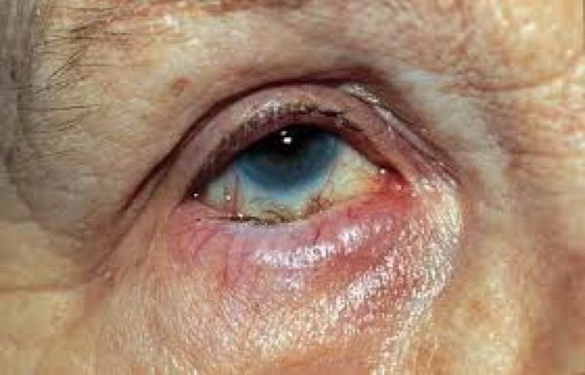  Entropion  Lid margin rolled IN, so the lashes sit against the globe  Slide 12 | 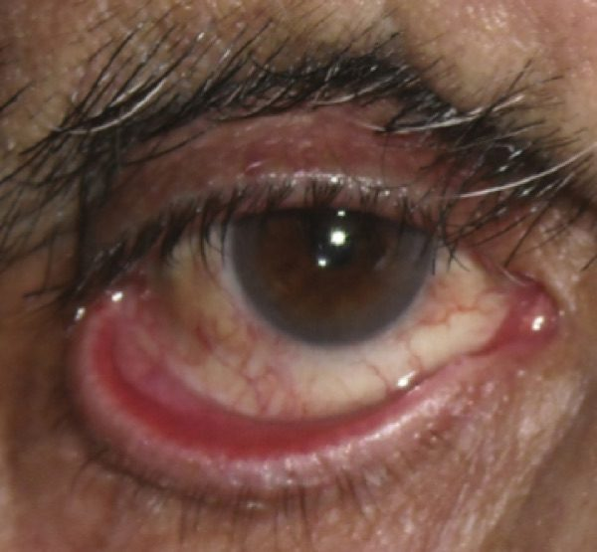  Ectropion  Lid margin rolled OUT, exposing the inner surface  Slide 12 | 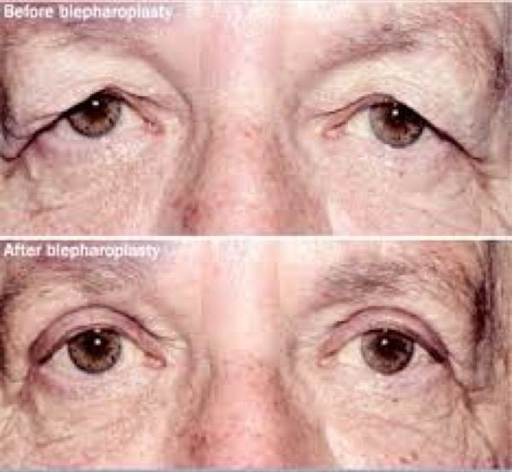  Dermatochalasis  Excess folds of upper lid skin hanging over the lashes  Slide 14
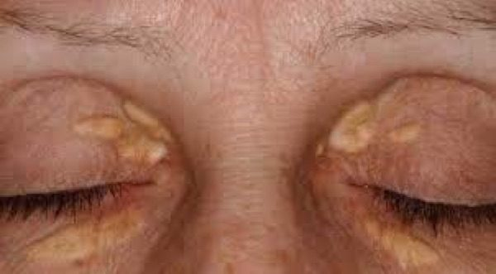  Xanthelasma  Oval yellow plaques on the nasal side of the lid  Slide 16 | 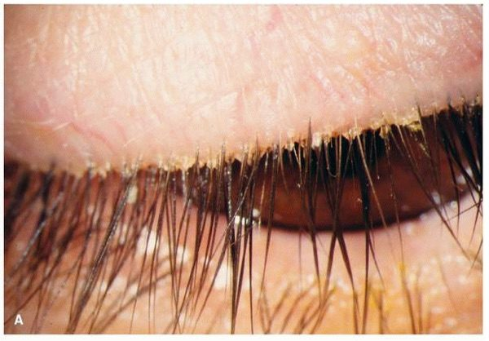  Blepharitis / Meibomitis  Crusting and collarettes at the base of the lashes  Slide 18 | 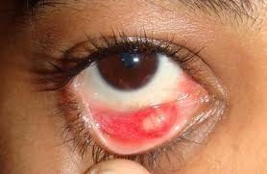  Chalazion  Focal, NON-tender lid swelling built over days to weeks  Slide 20
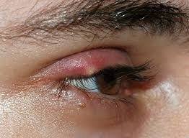
Hordeolum (stye)
TENDER red nodule at the lid MARGIN — an external stye
Slide 20

 | Entropion | Ectropion
Lid margin | Turns IN | Turns OUT
Symptom | Foreign body sensation | Tearing
Complication | Lashes onto the globe (trichiasis) → corneal abrasion | Exposure keratopathy
Causes
Management

Dermatochalasis — excess loose skin with orbital fat prolapse, from ageing. Patients say the lids feel heavy and they are looking through their lashes. Examine the visual fields: a demonstrated deficit is what gets blepharoplasty covered by insurance.
Xanthelasma — oval yellowish plaques, typically asymptomatic, from metabolic disorders with raised serum lipids. Work up the metabolism: lipid profile, plus fasting glucose and haemoglobin A1C for diabetes, plus liver function. Treat the underlying issue; local options are cryotherapy, laser ablation, chemical peel or excision. Recurrence is common even after effective local treatment. One caveat: many patients have entirely normal lipids, and the profile is still reasonable.
Blepharitis and meibomitis — associated with rosacea, seborrhoeic dermatitis, and Staphylococcus aureus colonisation. Burning, dryness, grittiness, itching, foreign body sensation, tearing. Signs: crusting and scaling at the lash bases, erythematous swollen lid margins, and thick, sometimes toothpaste-like lipid secretion from the meibomian glands, with a decreased or frothy tear film. Lid hygiene first. If no improvement after two weeks, topical antibiotics, then oral. Chronic — controlled rather than cured.
 | Chalazion | Hordeolum (stye)
Mechanism | Sterile obstruction of a meibomian gland | Acute infection, usually staphylococcal — meibomian (internal) or Zeis/Moll (external)
Onset | Days to weeks | 24 hours or overnight
The discriminator | NON-tender | TENDER
First-line
If it persists | Ophthalmology for steroid injection or curettage. Improvement may take months. | Ophthalmology for incision and drainage if no improvement in 2 weeks

Refer a recurrent chalazion, or one persisting beyond 2–3 months, to rule out sebaceous carcinoma. If a hordeolum is accompanied by pre-septal cellulitis, treat with systemic antibiotics on that pathway.

1.4 · Lacrimal disorders
What these look like
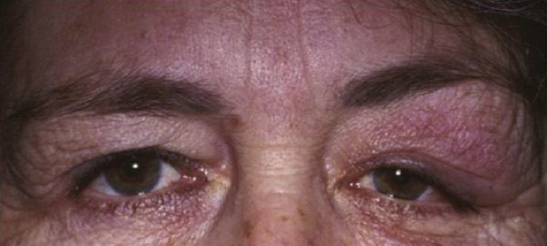  Dacryoadenitis  Swelling of the outer third of the UPPER lid  Slide 22 | 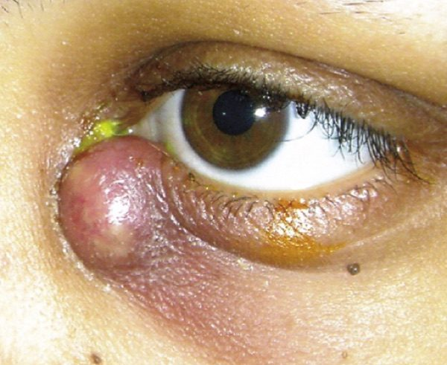  Dacryocystitis  Swelling BELOW the medial canthal tendon, pus from the punctum  Slide 24

 | Dacryoadenitis (GLAND) | Dacryocystitis (SAC)
Where | Lateral one third of the UPPER lid | Nasal aspect of the LOWER lid, below the medial canthal tendon
Cause | Inflammatory most common; bacterial rare; viral usually bilateral | Nasolacrimal duct obstruction
Extra signs | Ipsilateral preauricular node, temporal conjunctival injection, fever, leukocytosis | Mucoid or purulent discharge expressible from the lower punctum
Treatment | Inflammatory → corticosteroids, response within 48 h. Viral → cool compresses. Cause unclear → empiric oral antibiotics 24 h then reassess | Well & reliable → oral antibiotics 10 days. Febrile, ill or unreliable → admit, IV 48–72 h then oral to complete 10–14 days

NOTE
Do not start corticosteroids for dacryoadenitis until bacterial and other infectious causes have been reasonably excluded. And a mass ABOVE the medial canthal tendon is not dacryocystitis — suspect a lacrimal sac tumour, rare as it is.
Once dacryocystitis settles, probing and irrigation are often needed to assess whether the drainage system is patent; surgery may follow. Expect improvement 24–48 hours after antibiotics start.

1.5 · Conjunctiva and ocular surface
What these look like
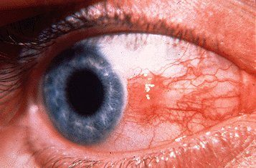  Pinguecula  Yellow nodule on the conjunctiva that STOPS at the limbus  Slide 27 | 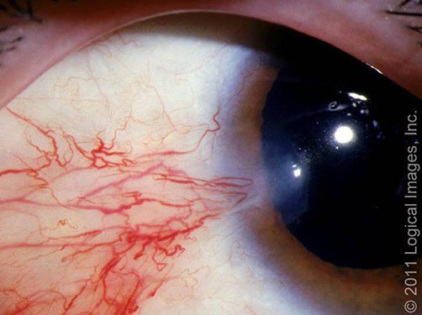  Pterygium  Wing of tissue that has CROSSED onto the cornea  Slide 27 | 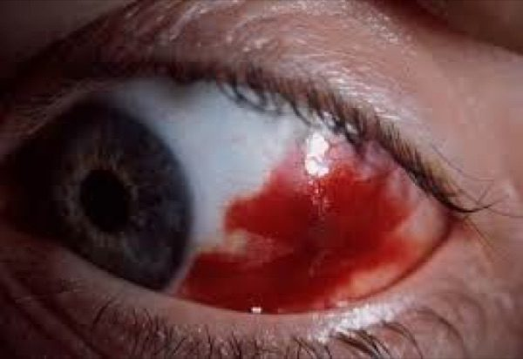  Subconjunctival haemorrhage  Flat sheet of blood under the conjunctiva, cornea clear  Slide 29
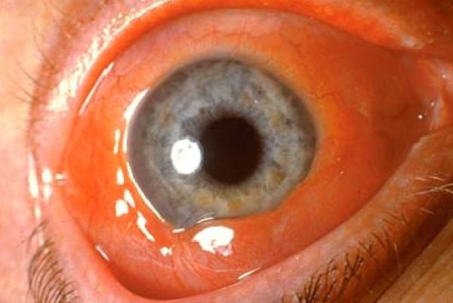
Chemosis
The conjunctiva itself swollen and ballooning
Slide 31


Left, pinguecula — the yellowish nodule stops at the limbus. Right, pterygium — the growth crosses onto the cornea. That crossing is the entire distinction. Slide 27
Pinguecula and pterygium both come from chronic sun and wind exposure and sit almost always at 3 o'clock or 9 o'clock. The whole distinction: the pterygium extends onto the cornea, the pinguecula does not. The mnemonic: pterodactyls fly (into the cornea), penguins can't. Protect from sun, dust and wind; lubricating drops. Conservative management will not make it resolve. Non-urgent referral if it grows or vision is affected; surgery if it distorts vision.
Subconjunctival haemorrhage (atraumatic) — Valsalva, bleeding disorder, antiplatelet or anticoagulant medication, hypertension. Blood under the conjunctiva, no pain, normal vision and pupil, clear cornea. History is the whole workup, and check the blood pressure if there is no explanation. Reassurance; resolves in 2–4 weeks.
NOTE
The patient-education point she spent time on. The eye clears the way a bruise does — red, then purplish, then brown, then yellow. Warn them about the yellow stage: “there will be a point that they look like they’re jaundiced … so they don’t come thinking that they’re in liver failure. People do know yellow eyes and liver failure, they seem to know that association.”
And a general rule she gave alongside it: anybody who comes in with any eye condition, check their vision — with their contacts or glasses in, because what you want to know is whether it has changed.

For recurrence, what is wanted is medication review, blood pressure and targeted evaluation — not automatic haematology referral.
Chemosis is conjunctival swelling — a sign, not a diagnosis. Non-specific for irritation: allergy, infection, thyroid eye disease, angioedema, trauma, orbital cellulitis, impaired orbital venous drainage. Chemosis WITH proptosis, restricted movement, reduced vision or an afferent pupillary defect is urgent.

1.6 · Conjunctivitis, all of it
What these look like
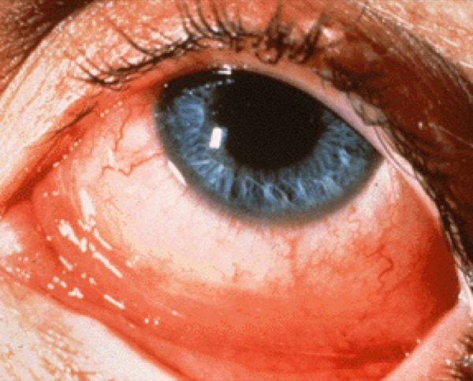  Allergic conjunctivitis  Cobblestone papillae under the lid, and no node  Slide 34 | 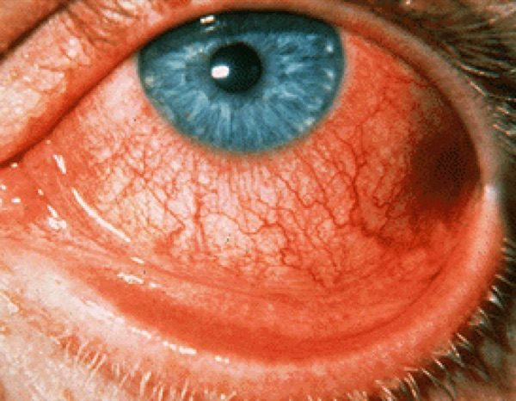  Viral conjunctivitis  Follicles plus watery discharge; the node is tender  Slide 36 | 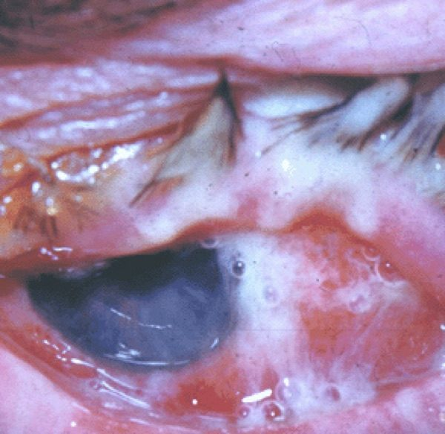  Bacterial conjunctivitis  Papillae with thick yellow discharge gluing the lashes  Slide 40
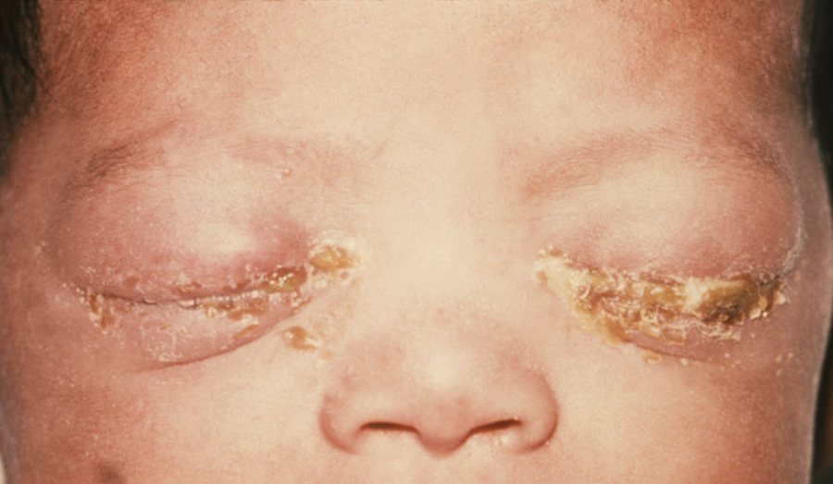  Gonococcal conjunctivitis  Severe purulent discharge, hyperacute over hours  not on a slide — CDC / J. Pledger , Public Health Image Library #3766 · public domain | 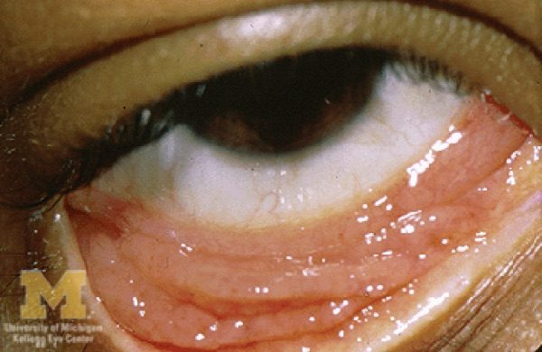  Chlamydial conjunctivitis — adult inclusion  Follicles persisting beyond a month  Slide 42 | 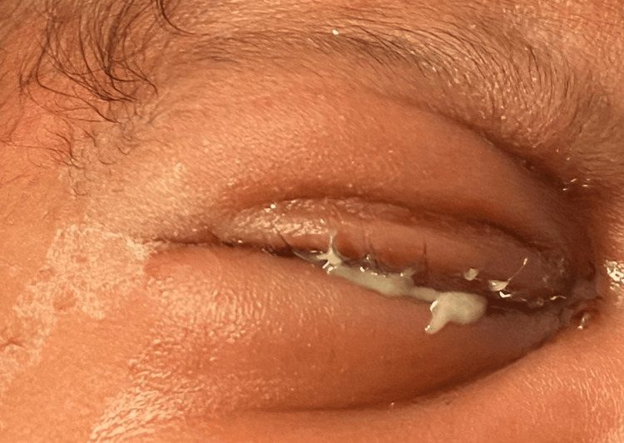  Chlamydial conjunctivitis — neonatal  Conjunctivitis in a neonate, days after birth  not on a slide — Nwokeji I, Ding K, Ketner S , Cureus 2024;16(7):e64463 · CC BY 4.0
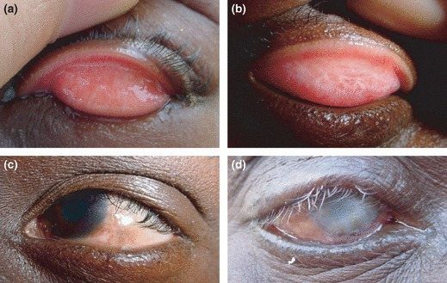  Trachoma  Upper lid follicles, then scarring that turns the lid in  not on a slide — Hu VH and colleagues , Trop Med Int Health 2010;15(6):673–91 · CC BY 2.5 | 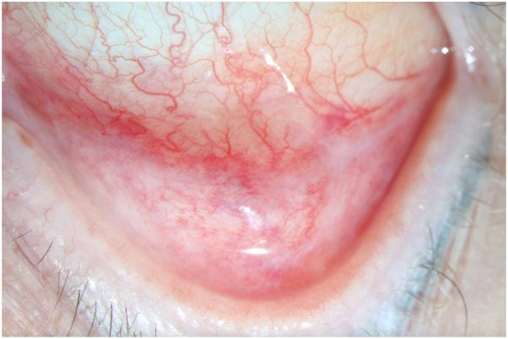  Autoimmune conjunctivitis  Recurrent redness with scarring of the fornix  not on a slide — Nguyen CDT, Cao J, Dominguez AR , JAAD Case Rep 2025;64:95–99 · CC BY 4.0

Acute is 4 weeks or less; chronic is more than 4 weeks. Two examination findings do most of the sorting:
Finding | Appearance | Points to
Papillae | Red at the surface, paler at the base — her analogy: “it almost looks like a strawberry” | Bacterial (except chlamydial), allergic
Follicles | Pale at the surface, redder at the base | Chlamydial, viral
Preauricular node | — | Chlamydial, gonococcal, viral

Type | Giveaway | Treatment
Allergic | ITCH, bilateral, watery/stringy discharge, chemosis, papillae, no node | Avoid the allergen; cool compresses, artificial tears, topical histamine blocker ± mast cell stabiliser (olopatadine does both), systemic antihistamine
Viral | Adenovirus. Profuse watery discharge, follicles, tender preauricular node. Starts one eye, spreads to the other. Recent upper respiratory infection | Cool compresses, artificial tears, contagious precautions. Self-limiting: often worse over week one, resolving in 2–3 weeks. Refer if >3 weeks, or photophobia or vision loss after onset
Bacterial | Thick yellow/white discharge, often unilateral, papillae, usually no node | Immunocompetent adult: topical broad-spectrum antibiotic (e.g. fluoroquinolone) + contagious precautions
Gonococcal | Severe purulent discharge WITH a palpable preauricular node — the exception to the no-node rule | Newborn = emergency. Hospitalise, systemic ceftriaxone, cultures and Gram stain, test for chlamydia and dissemination. Untreated risk: corneal perforation
Chlamydial (adult inclusion) | Serotypes D–K. Chronic (a month or more), stringy mucoid discharge, follicles, unresponsive to topical medication. Often concurrent asymptomatic urogenital infection | Confirm with conjunctival nucleic acid amplification or direct fluorescent antibody. Doxycycline 100 mg twice daily for 7 days. Evaluate for other sexually transmitted infections; notify partners
Chlamydial (neonatal) | Serotypes D–K from maternal secretions; may have pneumonia | Erythromycin 50 mg/kg/day divided four times daily for 14 days. Monitor infants under 6 weeks for infantile hypertrophic pyloric stenosis — erythromycin is a motilin receptor agonist
Autoimmune | Recurrent/chronic hyperaemia, minimal pain, NO discharge, systemic complaints. Pemphigoid, Stevens-Johnson, Sjögren, graft-versus-host | Routine ophthalmology referral

NOTE
Trachoma — serotypes A, B, C, and the leading infectious cause of blindness worldwide. Most active cases are asymptomatic. Mass drug administration with azithromycin 1 g orally as a single dose where prevalence is ≥5 per cent. The chain to blindness is worth memorising: conjunctival inflammation → eyelid scarring → entropion → trichiasis → blindness. Trichiasis needs surgery.

Urgent ophthalmology in bacterial conjunctivitis if: immunocompromised, contact lens wearer, recent eye surgery, foreign body, corneal opacity or suspected keratitis, or no improvement in 24 hours.

1.7 · Episcleritis and scleritis
What these look like
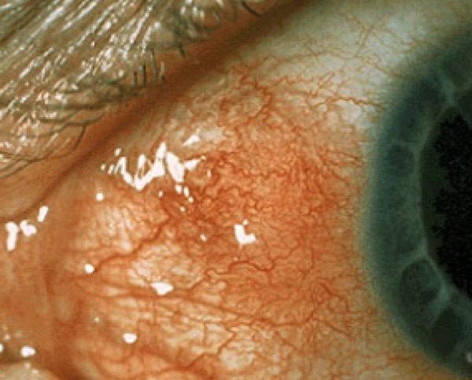  Episcleritis  Sectoral redness; the vessels move when swept  Slide 47 | 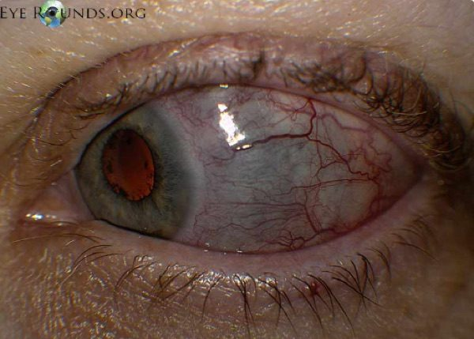  Scleritis  Deep violaceous hue; the vessels do NOT move  Slide 49

 | Episcleritis | Scleritis
Aetiology | Often idiopathic, often no systemic association | Often systemic autoimmune
Pain | Mild, acute onset, focal. No discharge, no photophobia | Severe boring pain, worse at night, radiating to face and periorbital region
Appearance | Redness, often sectoral | Violaceous hue — choroid showing through thinned sclera. Pain with eye movement
Cotton-tip test | Vessels CAN be moved slightly | Vessels CANNOT be moved
Confirmatory test | 2.5% phenylephrine, wait 15 minutes — vessels blanch | —
Management | Artificial tears + oral anti-inflammatory taken WITH FOOD. Refer if no response in 2 days | URGENT referral. Slit lamp and fundoscopy, work up the systemic cause. Sclera at risk of perforation, may need a surgical patch
Prognosis | Usually self-limited; may recur in either eye | Decreased PAIN is the first sign of response, even if the inflammation looks unchanged

A refinement worth carrying: non-infectious anterior scleritis commonly begins with systemic non-steroidal anti-inflammatories, with corticosteroids and immunomodulators for severe, necrotising, posterior or refractory disease — and perforation risk is greatest in necrotising disease, not uniformly.

1.8 · Keratitis and corneal ulcer
What these look like
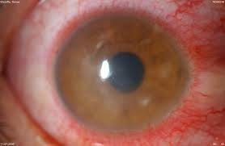  Keratitis  Corneal opacification with ciliary flush around the limbus  Slide 55 | 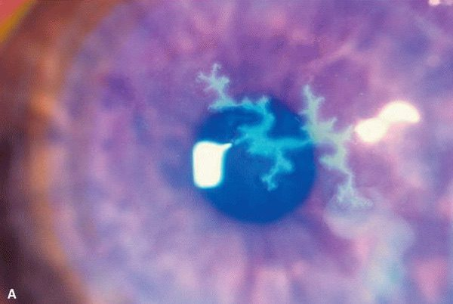  Herpes simplex keratitis  Branching dendrite with TERMINAL END BULBS on fluorescein  Slide 57 | 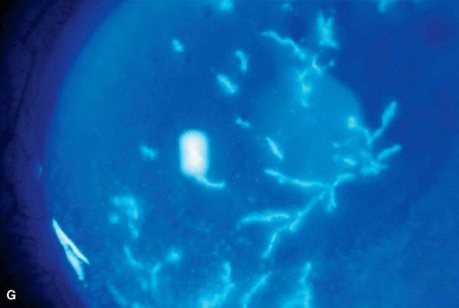  Herpes zoster keratitis  Pseudodendrite without end bulbs, in a dermatomal rash  Slide 57
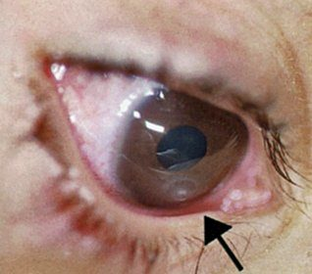
Corneal ulcer
White corneal infiltrate with an overlying epithelial defect
Slide 60

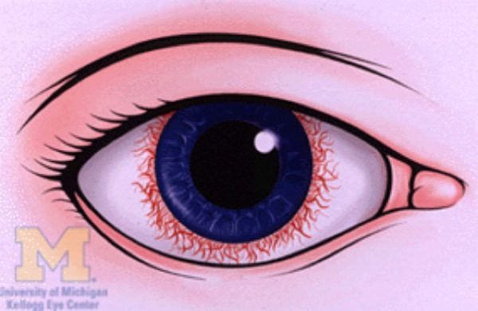
Ciliary flush — a ring of vessels radiating from the limbus around the cornea. This is the finding that rules OUT simple conjunctivitis. Slide 54
Ciliary flush — a ring of red vessels spreading from the limbus around the cornea, from the anterior ciliary arteries. It means inflammation of cornea, iris or ciliary body, and appears in corneal inflammation (ulcer, keratitis), anterior uveitis, and acute glaucoma. It is the finding that rules out simple conjunctivitis.
Keratitis. Risks: corneal trauma, dry eyes, contact lens overwear, topical ocular corticosteroids. Bacterial, viral, fungal; parasitic rare. Pain, foreign body sensation, tearing, photophobia, redness at the corneal edge, blurred vision. Signs: corneal opacification, a “broken up” corneal light reflection, ciliary flush. Classic ring infiltrate = Acanthamoeba, in lens wearers with poor hygiene such as rinsing lenses in tap water. Urgent referral within 24 hours for slit lamp with fluorescein. Undertreated → corneal scarring or perforation → endophthalmitis → possible removal of the eye.

Left, herpes simplex — a true dendrite: tree-branching, elevated edges, and terminal end bulbs . Pathognomonic. Right, herpes zoster — a pseudodendrite, which lacks all three. Slide 57
 | Herpes SIMPLEX keratitis | Herpes ZOSTER keratitis
Corneal sign | TRUE DENDRITE — tree-branching, elevated edges, terminal end bulbs. Pathognomonic | PSEUDODENDRITE — lacks the branch pattern, the elevated edges and the end bulbs
Patient | Often younger | Often older; rare in children; also immunosuppressed
Skin | Not dermatomal, may not respect the midline (only ~10% of primary disease is bilateral) | Dermatomal, most often V1, respects the midline, unilateral, often spares the lower lid. Hutchinson sign (nose tip) → higher ocular risk
Treatment
Prognosis | Good, benign, self-limited. Recurrences common under stress | Good to poor by corneal involvement. Postherpetic neuralgia can be devastating

NOTE
NO TOPICAL GLUCOCORTICOIDS BY THE PRIMARY CARE PROVIDER IN ACTIVE HERPES SIMPLEX EPITHELIAL DISEASE. That decision belongs to ophthalmology. Prevention: recombinant zoster vaccine for adults 50 and over, and immunocompromised adults 19 and over.

Corneal ulcer. Contact lens use is the major risk factor. Painful eye, the patient resists opening it, photophobia, foreign body sensation, tearing, blurred vision. Ciliary flush and a corneal defect. EMERGENT referral — a step above keratitis. Slit lamp, fluorescein, swab central or large ulcers for culture. Start a broad-spectrum topical agent (fourth-generation fluoroquinolone). Steroid drops can worsen infection if started too early — especially fungal or herpetic — so leave that to ophthalmology. Next-day follow-up; most heal in 2–3 weeks; untreated can blind; severe cases may need a transplant.

1.9 · Uveitis
What these look like
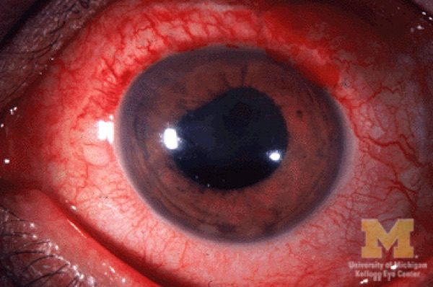  Anterior uveitis (iritis, iridocyclitis)  Ciliary flush with an irregular pupil  Slide 62 | 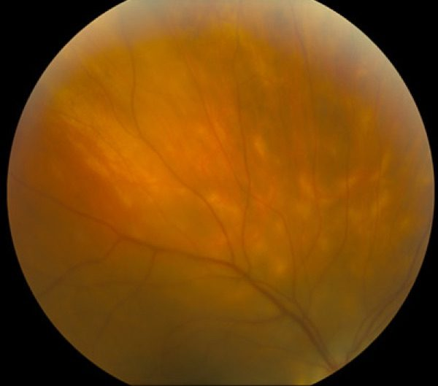  Posterior uveitis (choroiditis, retinitis)  Vitreous haze obscuring the retinal detail  Slide 64

 | Anterior (iritis, iridocyclitis) | Posterior (choroiditis, retinitis)
Aetiology | Idiopathic, autoimmune | Idiopathic, autoimmune, infectious — toxoplasmosis, cytomegalovirus
Pain | Yes — with photophobia and redness at the corneal edge | NO pain if isolated
Vision | Often preserved | Blurred, with floaters, scotomas, metamorphopsia
Signs | Cells in the anterior chamber, consensual photophobia, ciliary flush, variable pressure, irregular pupil stuck to lens or cornea, keratic precipitates (white cell deposits on the corneal endothelium) | Cells in the posterior vitreous, vitreous haze, retinal or choroidal inflammation
Referral | Urgent, within 24 h — delay may cost vision | Refer for slit lamp and dilated fundoscopy; possibly fluorescein angiography to separate active from inactive lesions
Treatment | Infectious → treat the organism. Non-infectious → topical corticosteroids | Does NOT respond to topical treatment — may need an intraocular corticosteroid injection
Course | Most acute cases respond dramatically in days to weeks | Develops far more slowly, may last years

Recurrent uveitis, or uveitis with features suggesting systemic autoimmune disease, needs a thorough systemic evaluation. And infection must be excluded before immunosuppression.

1.10 · Pre-septal and post-septal cellulitis
What these look like
  Pre-septal (periorbital) cellulitis  Lids swollen but THE EYE ITSELF IS WHITE  Slide 52 | 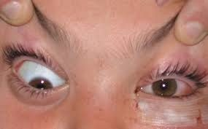  Post-septal (orbital) cellulitis  PROPTOSIS with restricted, painful eye movement  Slide 52


Left, pre-septal — the lid is swollen and red but the eye itself is white , and movements are full and painless. Right, post-septal — the globe is involved. This is the single most useful visual discrimination in the block. Slide 52
Both come from direct extension from a bacterial sinus, skin or dental infection. In diabetic, elderly or immunocompromised patients, consider fungus — aspergillosis, mucormycosis.
 | PRE-septal (periorbital) | POST-septal (orbital)
The giveaway | The eye itself is WHITE | The eye itself is RED and cannot move fully
Symptoms
Post-septal only | — | Pain and difficulty with eye movement, reduced vision, diplopia
Signs | Diffuse balloon-like lid oedema, erythema, tenderness; variable conjunctival injection | Significant injection, proptosis, decreased and painful movement, possible afferent pupillary defect, decreased vision
Management | Mild → outpatient oral antibiotics 10–14 days against Staphylococcus (including resistant strains) and Streptococcus | ALL post-septal → hospitalise, broad-spectrum IV 48–72 h, then oral at least a week

Also admit a pre-septal patient if: moderate-severe or toxic, poor compliance expected, a child of 5 years or younger, or no improvement after oral antibiotics started.
Workup: contrast computed tomography of orbits and paranasal sinuses, complete ocular examination with fundoscopy, Gram stain and culture of any drainage, complete blood count with differential, blood cultures. May need ear-nose-throat, oral and maxillofacial surgery, or infectious disease consults. Untreated → intracranial spread → meningitis or cavernous sinus thrombosis. Expect improvement in 24–48 hours.
Notes caveat: mild, clearly pre-septal disease with normal vision, pupils and painless full movements may be managed clinically without routine imaging.

1.11 · Referral timing — explicit disposition
Same caveat as 1.1 — this table comes from the section she called extra material and said she would not pull test questions from. Worth knowing; not examinable.
Urgency | Conditions
EMERGENT — now | Chemical injury (irrigate first), open globe, acute angle closure, orbital cellulitis, endophthalmitis
SAME DAY | Keratitis or corneal ulcer, anterior uveitis, scleritis, ocular herpes zoster ophthalmicus
URGENT — 24–48 hours | Unexplained decreased vision, persistent pain or photophobia, atypical or worsening red eye
ROUTINE | Uncomplicated conjunctivitis, chronic eyelid or ocular surface disease

Routine is only appropriate when ALL of these hold: acuity preserved, pupils and movements normal, cornea clear with no fluorescein uptake or infiltrate, no significant pain or photophobia, and reliable follow-up. Every assessment ends with a documented disposition and a safety net — acuity, key negatives, suspected diagnosis, urgency, destination, and explicit return precautions.
First-line treatment
Every condition in this lecture, with what you reach for first and how fast — which in ophthalmology is half the answer. Where the deck escalates after a failed trial, only the first step is here; the full ladder and the reasoning are in the comparison chart.
Condition | First line | How fast
Entropion | Preservative-free artificial tears by day, lubricating ointment at night, tape the exposed lid. | Routine
Ectropion | Same as entropion: tears by day, ointment at night, taping. | Routine
Dermatochalasis | Blepharoplasty. | Routine
Xanthelasma | Treat the underlying metabolic issue. Local: cryotherapy, laser ablation, chemical peel, surgical excision. | Routine
Blepharitis / Meibomitis | Lid hygiene first. | Routine
Chalazion | Warm compresses with gentle massage. | Routine
Hordeolum (stye) | Warm compresses with gentle massage. | Routine
Dacryoadenitis | Inflammatory → corticosteroids. Viral → cool compresses. Cause unclear → empiric oral antibiotics 24 h then reassess. Analgesia as needed. | Urgent
Dacryocystitis | Well, afebrile, reliable → oral antibiotics 10 days. Febrile, ill or unreliable → admit, intravenous 48–72 h then oral to complete 10–14 days. Warm compresses; consider drainage of an abscess. | Urgent
Pinguecula | Sun, dust and wind protection; lubricating drops. | Routine
Pterygium | Sun protection and lubricating drops. | Routine — refer non-urgently if growing or vision affected
Subconjunctival haemorrhage | Reassurance. Artificial tears if mildly irritated. Treat the underlying bleeding disorder or hypertension. | Routine
Chemosis | Treat the cause. | URGENT if with proptosis, restricted movement, reduced vision or an afferent pupillary defect
Allergic conjunctivitis | Avoid the allergen; cool compresses, artificial tears, topical histamine blocker ± mast cell stabiliser (olopatadine does both), systemic antihistamine. | Routine
Viral conjunctivitis | Cool compresses, artificial tears. Contagious precautions and hand hygiene. | Routine — refer if >3 weeks, or photophobia or vision loss after onset
Bacterial conjunctivitis | Immunocompetent adult → topical broad-spectrum antibiotic (e.g. fluoroquinolone). Contagious precautions. | Routine — URGENT if immunocompromised, contact lens wearer, recent surgery, foreign body, corneal opacity, or no improvement in 24 h
Gonococcal conjunctivitis | Newborn: hospitalise, systemic ceftriaxone once, specialty consultation. | EMERGENT
Chlamydial conjunctivitis — adult inclusion | Doxycycline 100 mg orally twice daily for 7 days. | Routine
Chlamydial conjunctivitis — neonatal | Erythromycin 50 mg/kg/day divided four times daily for 14 days. Azithromycin 20 mg/kg daily for 3 days is an alternative with more limited data. | Urgent
Trachoma | Mass drug administration: azithromycin 1 g orally as a single dose where prevalence is ≥5%. Trichiasis requires surgery. | Urgent
Autoimmune conjunctivitis | Managed by ophthalmology alongside the systemic disease. | Routine
Episcleritis | Artificial tears and an oral non-steroidal anti-inflammatory taken WITH FOOD. | Routine — refer if no response in 2 days
Scleritis | Non-infectious anterior disease commonly begins with systemic anti-inflammatories; systemic corticosteroids and immunomodulators for severe, necrotising, posterior or refractory disease. | SAME DAY — sclera at risk of perforation, may need a surgical patch
Pre-septal (periorbital) cellulitis | Mild → outpatient oral antibiotics 10–14 days against Staphylococcus (including resistant strains) and Streptococcus. | Urgent — admit if moderate-severe or toxic, poor compliance, child ≤5 years, or no improvement on orals
Post-septal (orbital) cellulitis | Hospitalise — broad-spectrum intravenous antibiotics 48–72 h, then oral for at least a week. May need ear-nose-throat, oral and maxillofacial surgery, or infectious disease consults. | EMERGENT
Keratitis | Treat the underlying cause to prevent persistent inflammation and scarring, guided by ophthalmology. | SAME DAY — urgent referral within 24 h
Herpes simplex keratitis | Oral antivirals (aciclovir, valaciclovir, famciclovir) for 10 days. | SAME DAY
Herpes zoster keratitis | Oral antivirals for 10 days, ideally within 72 hours of rash onset. Intravenous aciclovir for severe, disseminated, orbital, retinal, central nervous system or significantly immunocompromised disease. | SAME DAY
Corneal ulcer | Broad-spectrum topical agent (fourth-generation fluoroquinolone) to start; then agent-specific therapy per ophthalmology. | EMERGENT
Anterior uveitis (iritis, iridocyclitis) | Infectious → treat the organism. Non-infectious → topical corticosteroids. | SAME DAY — urgent within 24 h, because delay may cost vision
Posterior uveitis (choroiditis, retinitis) | Does NOT respond to topical treatment — may require an intraocular corticosteroid injection. | Urgent

1.12 · The eye in three layers
Every disorder in this block sits in one of three tunics, and naming the layer usually names the kind of problem.
Layer | Structure | What it does
Fibrous  outer | Cornea | Transparent front surface; provides most of the eye's focusing power
Sclera | Tough white coat; maintains shape and gives the muscles their attachment
Vascular (uvea)  middle | Iris | The coloured part; controls pupil size and so regulates light entry
Ciliary body | Produces aqueous humour and controls lens accommodation
Choroid | Highly vascular; nourishes the retina
Neural  inner | Retina | Rods and cones convert light into neural signals
Macula | Central vision
Fovea | Highest visual acuity
Optic disc | Where the optic nerve exits — the blind spot

Useful shorthand: uveitis is inflammation of the middle layer, which is why it takes iris, ciliary body and choroid together; scleritis and episcleritis sit in the outer; and the vascular occlusions and detachments are all inner-layer disease.

2 · Neuro-Ophthalmology
INSTRUCTIONAL OBJECTIVES
OPHTHALMOLOGY — Neuro-ophthalmology
- Describe nystagmus
- Describe the afferent pupillary light pathway.
- Describe the parasympathetic (efferent pupillary) pathways.
- Describe the sympathetic pathways (oculo-sympathetic).
- Describe the accommodation reflex.
- Compare and contrast the etiologies, epidemiology, risk factors, clinical manifestations, differential diagnosis, diagnostic testing (including ordering and interpretation), management (acute and chronic, including applicable rehabilitative and palliative care), appropriate referrals, patient education, and prognosis of the following common neuro-ophthalmological disorders:
- Relative afferent pupillary defect (Marcus Gunn pupil)
- Horner syndrome
- Argyll Robertson pupil
- Adie tonic pupil
- Cranial nerve III, IV, and VI palsies
- Ptosis
- Anisocoria
- Differentiate the clinical presentation of pre-and post-chiasm lesions.
- Identify medical care strategies for ophthalmological disorders in the lecture topic list for the following populations: a. adult · b. elderly

NOTE
How to read this section. Almost every diagnosis here is decided by which pupil is the abnormal one and what it does in the dark. Get the four pathways straight first — afferent light, parasympathetic efferent, sympathetic, and near/accommodation — and the named pupils fall out of them rather than needing to be memorised as a list.

2.1 · Nystagmus Objective a
What these look like
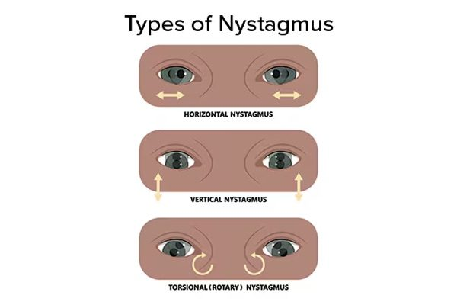
Nystagmus
Involuntary rhythmic oscillation, named for the FAST beat
Slide 4

Definition: an involuntary, biphasic, rhythmic, tremor-like oscillating movement of the eyes. It is either congenital (infantile or latent) or acquired.
It is usually symptomatic — unless it was acquired before the age of 8. That single exception is the reason a child with long-standing nystagmus may report nothing at all. Symptoms, when present:
Symptom | What the patient means
Vertigo | The patient or the room is spinning. Often the primary symptom, and commonly points to a vestibular problem.
Oscillopsia | The environment or an object appears to move back and forth.
Blurred vision | The retinal image is being dragged by the oscillation.
Abnormal head position | A compensation for the blurring, not a separate problem.

Jerk nystagmus is classified by trajectory and named for the direction of the FAST beat — vertical, horizontal or torsional. It increases with gaze in the direction of the fast phase. Horizontal jerk nystagmus is the most common form: the eyes drift slowly to one side and snap quickly back.

The three trajectories — horizontal , vertical and torsional (rotary) . Jerk nystagmus is classified by trajectory and named for the direction of the fast beat. Slide 4
NOTE
Who gets referred and worked up. Infants and young children with nystagmus; nystagmus acquired during adolescence or adulthood; and concerning or non-physiologic nystagmus in adults. The pathway is ophthalmology for a complete ophthalmic exam → initial imaging → labs if relevant, and in every case the underlying aetiology must be addressed. Slide 5

2.2 · The three pupillary pathways Objectives b, c, d
Start with pupil size itself. Pupillary size is set by the AVERAGE of the illumination detected by each eye. Cover one eye of a normal person and watch the other: the pupil enlarges, because the average illumination has effectively been halved. That one fact explains why the swinging flashlight test works at all.
Pathway | Route | Effect
Afferent light  (objective b) | Retinal ganglion cells → CN II → optic tracts → synapse in the pretectal nuclei. Each pretectal nucleus sends axons to BOTH Edinger-Westphal nuclei. | This bilateral crossing is why light in one eye constricts both pupils.
Parasympathetic efferent  (objective c) | Preganglionic fibres from the Edinger-Westphal nucleus travel along CN III to the ciliary ganglion, then short ciliary nerves to the iris sphincter. | MIOSIS
Sympathetic (oculo-sympathetic)  (objective d) | First order hypothalamus → brainstem and cervical cord, synapsing at the ciliospinal centre of Budge, C8–T2. Second order exits the cord, loops up through the brachial plexus over the lung apex to the superior cervical ganglion. Third order follows the carotid to the radial muscle of the iris. | MYDRIASIS

NOTE
Why the three-neuron sympathetic chain is worth the effort. The whole of Horner syndrome localisation below is just which of those three neurons is damaged. The second-order neuron's detour over the lung apex is why a Pancoast tumour causes it, and the third-order neuron's ride along the carotid is why a dissection does.
Opioids are parasympathomimetics. Overdose gives reduced mental status, respiratory depression under 12 per minute, reduced tidal volume, and pupillary constriction. It is the mental status and the respiration that matter clinically, not the pupil. Reversal is naloxone, preferably intravenous, now available over the counter as an intranasal preparation. Slide 12

2.3 · The accommodation reflex, and light-near dissociation Objective e
On shifting gaze from far to near, three things happen — to the lens, the pupil and the globes. All three share one afferent limb: retinal input via CN II and the optic tract to the lateral geniculate nucleus and visual cortex.
Component | What happens | Result
Lens | Ciliary smooth muscle contracts | Lens becomes more convex → increased refractive power
Pupil | Constriction | Improves up-close focus
Globes | Both eyes adduct | Convergence

The key asymmetry. The pupillary near response travels from visual cortex to iris sphincter skipping a portion of the route the pupillary light pathway takes. That difference is the entire basis of “light-near dissociation” — a pupil that will not react to light but still constricts to near. Argyll Robertson and Adie pupils both live in that gap.

2.4 · Anisocoria — deciding which pupil is abnormal Objective f7
The governing principle. The efferent limb of the pupillary reflex is bilateral, so both pupils receive the same command and should always be the same size. They should only be unequal when the efferent pathways are not working properly.
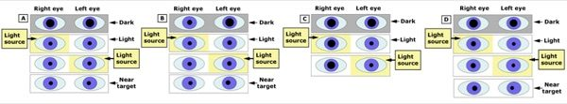
A normal — symmetric in light and dark. B the small pupil is abnormal — the right pupil does not dilate well in the dark . C the large pupil is abnormal — the right pupil does not react well to light . D physiologic anisocoria. Slide 20
Ask | If yes | Then the abnormal pupil is
Is the difference greater in the DARK? | The smaller pupil is failing to dilate | The SMALL one — think Horner, opioids, Argyll Robertson
Is the difference greater in the LIGHT? | The larger pupil is failing to constrict | The LARGE one — think CN III palsy, Adie, pharmacologic mydriasis
Is it equal in light and dark? | Both pupils are working | Physiologic anisocoria — the most common cause, usually under 0.4 mm difference

When the large pupil is abnormal, the causes are an ocular condition preventing constriction, or pharmacologic mydriasis. Anticholinergics give a pupil that is usually 8 mm or more and does not constrict to light at all — atropine and other anticholinergic mydriatic or cycloplegic drops are the classic culprits.

2.5 · The four named pupils Objectives f1–f4
What these look like
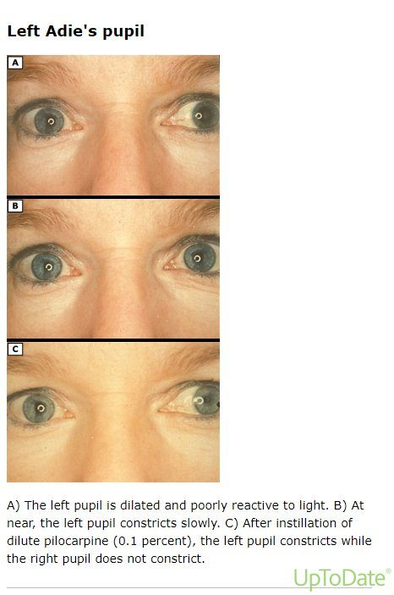  Adie tonic pupil  The LARGER pupil, reacting poorly to light  Slide 37 | 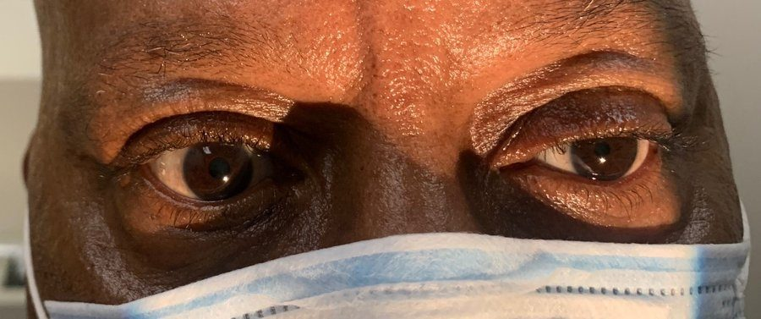  Horner syndrome  Ptosis and miosis on the same side  Slide 15

 | Marcus Gunn (RAPD) | Horner syndrome | Argyll Robertson | Adie tonic
Limb at fault | Afferent | Sympathetic | Pretectal / dorsal midbrain | Parasympathetic (ciliary ganglion)
Pupil size | Equal at rest | Miosis, unilateral | Miosis, BILATERAL | Mydriasis, often unilateral
Light reaction | Both pupils DILATE when the light swings to the affected eye | Normal | Absent | Poor
Near reaction | Normal | Normal | Brisk — light-near dissociation | Present but slow and tonic
Hallmark | Positive swinging flashlight test | DILATION LAG | Bilateral small pupils sparing near | Sector paralysis of the iris on slit lamp
Classic cause | Retina or optic nerve lesion | Damage anywhere along the sympathetic chain; often idiopathic | Tertiary syphilis | Inflammation of the ciliary ganglion, then aberrant reinnervation

Marcus Gunn pupil. An afferent defect, usually at the level of the retina or optic nerve. Moving a bright light from the unaffected eye to the affected eye makes both eyes dilate, because the ability to perceive that light is diminished — the average illumination the brain is working from has just dropped.
★ PROFESSOR EMPHASIS
★ Emphasised
Horner syndrome — dilation lag is the hallmark. The anisocoria is most evident in the first 4–5 seconds after dimming the lights, which is exactly when a normal sympathetic pathway would be actively dilating. After 10–15 seconds the pupil does dilate a little — but that is passive relaxation of the iris sphincter, not sympathetic function returning. Slide 29
Classic triad: ptosis, miosis, and anhidrosis — with the caveat that anhidrosis may be absent depending on where along the pathway the lesion sits. Diagnostic test: dilute apraclonidine drops, which are ineffective in a normal pupil but cause mydriasis in the Horner pupil.

Horner — neuron order | Causes
First order | Brainstem strokes and tumours; spinal cord lesions above T1
Second order | Pancoast tumour (superior pulmonary sulcus), thyroid cancer
Third order | Carotid dissection, cavernous sinus pathology

NOTE
The one that must not be missed. Carotid artery dissection, traumatic or spontaneous, can present with focal neurologic complaints and Horner syndrome — a third-order Horner. Cases have also been reported after COVID-19 with intubation and mechanical ventilation. Slide 15

Argyll Robertson pupil. Bilateral miosis; the pupils do NOT constrict to light but DO constrict quickly to near accommodation — light-near dissociation in its purest form. Classically tertiary syphilis, and those patients have other findings: tabes dorsalis from posterior column involvement, with sensory loss. The lesion is suspected to sit in the pretectal area of the superior colliculus (dorsal midbrain).
Adie tonic pupil (Holmes-Adie syndrome). Inflammation — infectious or autoimmune — damages the ciliary ganglion or the short ciliary nerves, followed by aberrant reinnervation. The affected pupil shows mydriasis with a poor light response. Typically women in their 30s, often unilateral; there may be photophobia and blurred vision but it is often asymptomatic. Look for sector paralysis on slit lamp, decreased regional corneal sensation, and absent Achilles or patellar reflexes.

2.6 · Cranial nerve III, IV and VI palsies Objective f5
What these look like
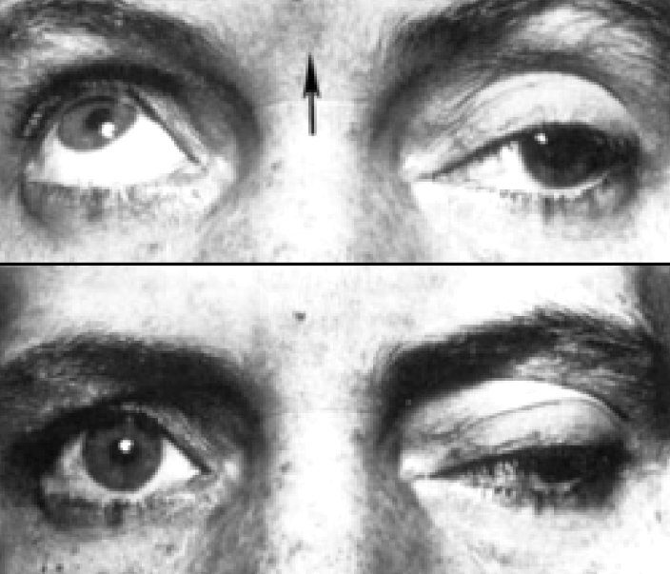  Cranial nerve III palsy  Ptosis with the eye down and out, pupil dilated  Slide 40 | 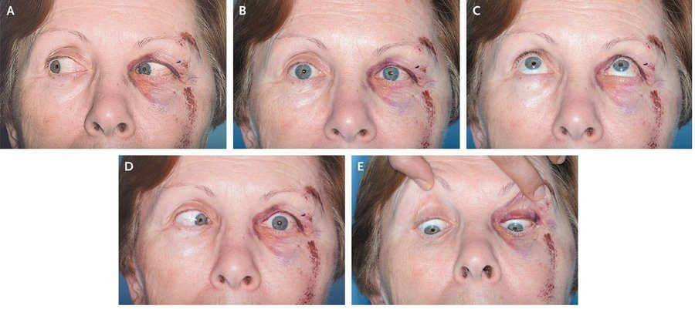  Cranial nerve VI palsy  The affected eye will not abduct  Slide 45

 | CN III (oculomotor) | CN IV (trochlear) | CN VI (abducens)
Muscle | Superior division: levator palpebrae, superior rectus. Inferior division: inferior rectus, medial rectus, inferior oblique, and parasympathetics to the ciliary ganglion | Superior oblique — intorts and depresses | Lateral rectus — abducts
Diplopia | With ptosis and mydriasis | VERTICAL, binocular, worse with postural head change | HORIZONTAL, binocular
Most common cause | Microvascular — diabetes, hypertension | Congenital when isolated, even in adults. Acquired → trauma, even mild, or microvascular | Children: intracranial tumours, especially brainstem and posterior fossa. Adults: microvascular; also major trauma or skull base fracture
The dreaded cause | Compression by an enlarging intracranial aneurysm, most commonly of the posterior communicating artery — threat of rupture within hours to days | — | —

★ PROFESSOR EMPHASIS
★ The decision that changes management
A third nerve palsy is classified two ways at once: complete versus incomplete, and pupil-INVOLVED versus pupil-SPARED.
Pupil involved | Pupil spared
STAT CTA head or MRA brain — this is the vascular pathway, and the aneurysm is what you are ruling out | Reassurance and imaging, but it does not need to be STAT

The anatomical reason: the parasympathetic fibres run on the outside of the nerve, so an external compression reaches them first, while microvascular disease infarcts the core and spares them. Slide 41

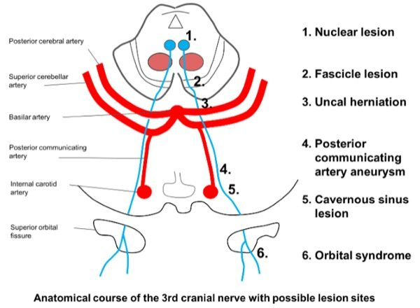
The course of CN III and where it can be struck: 1 nuclear, 2 fascicle, 3 uncal herniation, 4 posterior communicating artery aneurysm , 5 cavernous sinus, 6 orbital. Site 4 is the one the pupil-involved rule is built around. Slide 39
CN IV is the odd one out anatomically: it is the only nerve arising from the dorsal surface of the brainstem, and it crosses — the left trochlear nucleus sends fibres to the RIGHT eye. Clinically the patient tilts the head to the opposite side of the problem eye to compensate.
Situation | Management
Isolated, atraumatic CN IV or CN VI palsy | MRI brain with and without contrast. Check haemoglobin A1C if there are risk factors and no known diabetes.
Traumatic | Observe roughly 6 months before considering corrective treatment. In the interim, patch one eye to relieve binocular diplopia.
Congenital | Patching.

2.7 · Ptosis Objective f6
Definition: drooping of the upper eyelid from a congenital or acquired abnormality of the muscles that elevate it. Three structures hold the lid up, and knowing which is which is how you localise the cause:
Structure | Innervation | Role
Levator palpebrae superioris | CN III | Elevates the upper lid
Müller's muscle | Sympathetic | An additional 1–2 mm of elevation
Orbicularis oculi | CN VII | Closes the lids — the antagonist

 | Levator function | Laterality | The giveaway
CN III palsy | Reduced | Usually unilateral | Impaired extraocular movement and mydriasis in the same eye
Horner syndrome | NORMAL — only Müller's is out, hence the mild droop | Usually unilateral | Miosis in the same eye
Myasthenia gravis | Reduced | Unilateral or bilateral | Variable throughout the day — fatigability is the whole diagnosis

NOTE
Ptosis plus a SMALL pupil is Horner. Ptosis plus a LARGE pupil is a third nerve palsy. That one line resolves most of the exam questions in this objective, and the third possibility — ptosis that comes and goes through the day with a normal pupil — is myasthenia.

2.8 · Pre- and post-chiasm lesions Objective g
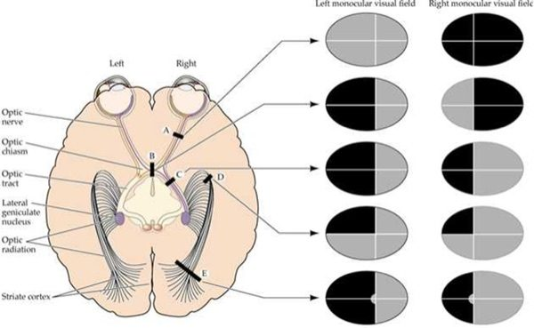
Lesion site A optic nerve, B chiasm, C optic tract, D optic radiation, E striate cortex — with the monocular field defect each produces. Slides 51–52
Lesion site | Field defect | Pre- or post-chiasm
Optic nerve | Total blindness of that eye | PRE — monocular, because the fibres have not crossed yet
Optic chiasm | Bitemporal (heteronymous) hemianopsia | At the chiasm — the crossing nasal fibres are hit
Optic tract | Left homonymous hemianopsia (for a right tract lesion) | POST
Optic radiation | Left superior quadrantanopia | POST
Striate cortex | Left homonymous hemianopsia WITH MACULAR SPARING | POST

NOTE
The rule that generates all five rows. A monocular defect is pre-chiasmal — one eye's fibres, before any crossing. A bitemporal defect is at the chiasm. Anything homonymous — the same side of the field in both eyes — is post-chiasmal, and the further back the lesion, the more congruent and the more likely to spare the macula.

2.9 · Care strategies, adult and elderly Objective h
The summary, in order: begin with a thorough history and physical examination; labs and imaging (head CT or brain MRI) if indicated; ophthalmology referral; and appropriate specialist referral — neurology, vascular surgery, or neurosurgery. Slide 54
Presentation | Urgency
CN III palsy with pupil involvement | EMERGENT — STAT CTA or MRA for aneurysm
Horner syndrome with neck pain, trauma or focal neurology | EMERGENT — carotid dissection
New nystagmus acquired in adolescence or adulthood | Work up — ophthalmology, imaging, labs
Isolated atraumatic CN IV or VI palsy | MRI with and without contrast; A1C if at risk
Pupil-sparing CN III palsy | Imaging, but not STAT

First-line treatment
Every condition in this lecture, with what you reach for first and how fast — which in ophthalmology is half the answer. Where the deck escalates after a failed trial, only the first step is here; the full ladder and the reasoning are in the comparison chart.
Condition | First line | How fast
Relative afferent pupillary defect (Marcus Gunn) | Treat the underlying retinal or optic nerve disease. | Urgent
Horner syndrome | Treat the cause. Levator function is normal, so the ptosis is mild. | Emergent
Argyll Robertson pupil | Treat the underlying syphilis. | Urgent
Adie tonic pupil | Reassurance; treat symptoms. Dilute pilocarpine constricts it through denervation supersensitivity. | Routine
Cranial nerve III palsy | Depends on aetiology. Traumatic: observe about 6 months, patching in the interim. | Emergent
Cranial nerve IV palsy | Traumatic: observe about 6 months before corrective treatment; patch one eye meanwhile. | Urgent
Cranial nerve VI palsy | Traumatic: observe about 6 months; patch one eye in the interim. | Urgent
Nystagmus | Ophthalmology for a complete ophthalmic exam → imaging → labs if relevant. The underlying aetiology must be addressed. | Urgent

2.10 · Nystagmus — the two classification groups
Nystagmus splits into two groups, and the split is the first thing to establish.
 | Jerk | Pendular
Phases | A slow phase and a fast phase | Both phases equal in velocity and amplitude — no fast phase at all
Named for | The direction of the FAST beat — vertical, horizontal or torsional | Not named by beat, since there is no fast beat
Behaviour | Increases with gaze toward the fast phase | Most often horizontal
Context | Most common form is horizontal jerk — eyes drift slowly one way, snap back | Usually congenital, or follows prolonged bilateral blindness beginning in childhood

The horizontal jerk subtypes: normal physiologic gaze-evoked, infantile, spasmus nutans, and latent nystagmus.
NOTE
Upbeat nystagmus is ALWAYS abnormal. It means a cerebellar or medullary lesion, and less commonly drug intoxication. It is present only on upward gaze. This is the one direction that carries its own alarm.

3 · Acute Vision Loss
INSTRUCTIONAL OBJECTIVES
OPHTHALMOLOGY — Acute Vision Loss
- Compare and contrast the etiologies, epidemiology, risk factors, clinical manifestations, differential diagnosis, diagnostic testing (including ordering and interpretation), management (acute and chronic, including applicable rehabilitative and palliative care), appropriate referrals, patient education, and prognosis of the following acute vision loss disorders:
- Amaurosis fugax
- Acute angle closure glaucoma
- Optic neuritis
- Retinal detachment
- Retinal vascular occlusion: a. Central retinal artery occlusion (CRAO) · b. Branch retinal artery occlusion (BRAO) · c. Central retinal vein occlusion (CRVO) · d. Branch retinal vein occlusion (BRVO)
- Anterior ischemic optic neuropathy (AION): a. Arteritic AION, associated with Giant cell (temporal) arteritis · b. Non-arteritic AION
- Identify medical care strategies for acute vision loss in the lecture topic list for the following populations: 1. adult · 2. elderly

★ PROFESSOR EMPHASIS
★ Said twice, and named a future examiner
Every single person who has sudden acute vision loss is having a stroke until proven otherwise. That is why everyone gets an MRA, even with no weakness, no numbness and no speech difficulty — because you can have a stroke with no other symptom than acute vision loss. She repeated the sentence and added that Professor Alaya will ask this question when you reach the emergency department rotation.

3.1 · The four questions that separate these diagnoses
Jaquith opened by telling the class which details to highlight, because these conditions overlap heavily and the discriminating information is in the history rather than the fundus:
Ask | Answer | Points toward
One eye or both? | One | Nearly all of them — amaurosis fugax, occlusions, detachment, optic neuritis, AION
Both | Papilledema, or a lesion at or behind the chiasm
Sudden or gradual? | Seconds, then recovers | Amaurosis fugax
Seconds, and stays | CRAO
Hours to days | Optic neuritis (and detachment advances over days)
Central or peripheral? | Peripheral first, central preserved | Chronic open-angle glaucoma — “tunnel vision”
Central, with colour desaturation | Optic neuritis
Painful or painless? | PAINFUL | Acute angle-closure glaucoma (severe, at rest), or optic neuritis (on eye movement)
PAINLESS | Everything else — amaurosis fugax, all four occlusions, detachment, AION, papilledema

NOTE
The word “curtain” belongs to TWO diagnoses. Jaquith flagged this explicitly: “there's a couple of conditions where they use the word curtain, so don't confuse it.” Amaurosis fugax — the curtain comes down and then lifts within seconds to minutes. Retinal detachment — the curtain comes down and stays, advancing over days. Duration is the discriminator, not the word.

3.2 · Amaurosis fugax Objective a1
Transient monocular vision loss, also called “fleeting blindness”. Lasts a few seconds to minutes. It can involve both eyes but is usually one.
NOTE
If it lasted hours, it was not a transient ischemic attack. Jaquith was explicit. Duration is the first filter you apply.

Facet | Content
Etiology | Retinal emboli of carotid (TIA) or cardiac origin; also retinal vascular spasm. Most commonly a TIA.
Risk factors | Older age, diabetes, hypertension, atherosclerosis, cardiac valve disease, intravenous drug use, sickle cell, coagulation disorders, Raynaud's
Manifestations | A “curtain” coming down, transient. Anything from mild blurring or fogging to complete blackness. May involve part or all of the field — upper or lower half, temporal or nasal, small central or paracentral areas, or the whole field. Painless.
Diagnosis | Carotid Doppler if a carotid source is suspected. Echocardiogram if cardiac. MRA to evaluate all the arteries for emboli — and per the flag above, everyone gets it.
Treatment | Treat the underlying cause — she called this the essential point. To reduce stroke risk: aspirin and clopidogrel. Carotid emboli → carotid endarterectomy. Raynaud's or vascular spasm → calcium channel blockers.
Prognosis | About 85% recover fully; the rest progress to a central retinal artery occlusion. Early evaluation reduces the risk of permanent visual loss.
Education | A TIA is a major warning sign that a stroke is coming. Transient does not mean benign.

3.3 · Glaucoma — acute closed-angle and chronic open-angle Objective a2
What these look like
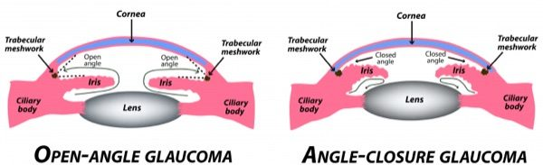  Acute angle-closure glaucoma  HAZY cornea with a fixed mid-dilated pupil  Slide 12 | 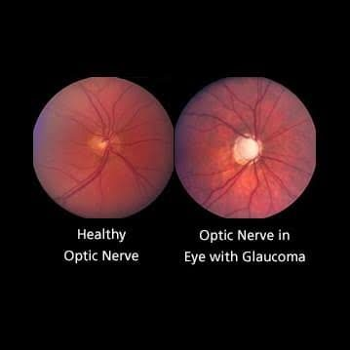  Chronic open-angle glaucoma  OPTIC NERVE CUPPING, with the rim thinned  Slide 19


Both forms raise intraocular pressure. In open-angle the angle is patent but the trabecular meshwork drains poorly; in angle-closure the iris mechanically shuts the circuit. Slide 12
 | ACUTE — closed angle | CHRONIC — open angle
Mechanism | The iris blocks the drainage circuit → intraocular pressure rises dramatically | Trabecular meshwork abnormality next to the canal of Schlemm, secondary to aging → optic nerve damage, with or without raised pressure
Frequency | Less common | MUCH more common
Pain | Severe and sudden eye pain | Painless
Symptoms | Decreased vision, coloured halos around lights, headache, nausea and vomiting | Asymptomatic in most patients. Peripheral field goes first — patients say “tunnel vision” — then complete blindness
Signs | Pupillary dilation, hazy cornea, bilateral narrow or occluded angle | Optic nerve cupping, rim pitting, bayoneting (vessels with narrow angulations), splinter haemorrhages, rim thinning, field defects
Pressure | 40–80 mmHg on tonometry or gonioscopy | May be normal OR elevated
Other risks | Systemic anticholinergics (atropine), nebulized bronchodilators, prior anterior uveitis, lens dislocation, African American race, obstruction from tumour or scarring | African American race, Hispanic ethnicity, adults over 40, diabetes, age, family history, hypertension, myopia
First-line | Topical pilocarpine (alpha-blocker) or timolol (beta-blocker); IV acetazolamide then mannitol or isosorbide | Latanoprost, tafluprost, timolol drops
Definitive | Laser peripheral iridotomy, 1–2 days after onset — lets fluid pass from the posterior to the anterior chamber | Laser trabeculoplasty if refractory or advanced. Surgery is definitive for both forms.


Optic nerve cupping — the widening and deepening of the central cup as nerve fibres are lost. Jaquith called it the classic sign , and the one a non-ophthalmologist can actually see. Slide 19
★ PROFESSOR EMPHASIS
★ The case she told twice
A patient went to the emergency department with an intractable headache — everything had been tried, nothing worked — and was admitted. After multiple doctors, a PA assessed him properly, found a red eye, and diagnosed glaucoma. The chief complaint was a headache, and it was localised behind the eye. Glaucoma is also a leading cause of blindness worldwide, and untreated it ends in blindness.

Patient education, and she meant it personally: everyone should have annual eye examinations — that screening is what finds asymptomatic chronic open-angle disease before the field is gone. Some patients stay on drops for life and never have surgery, when the surgical risk outweighs the benefit over their life expectancy.

3.4 · Optic neuritis Objective a3
What these look like
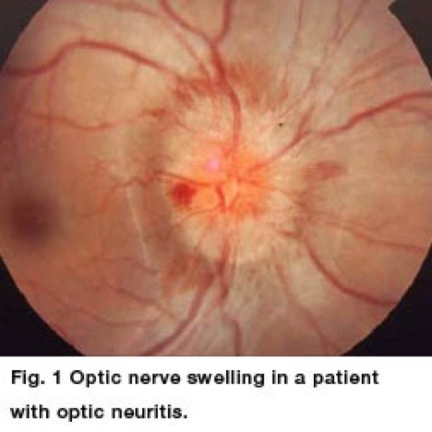  Optic neuritis — the disc  Disc swelling — but it looks like any swollen disc, so it is not diagnostic  Slide 23 | 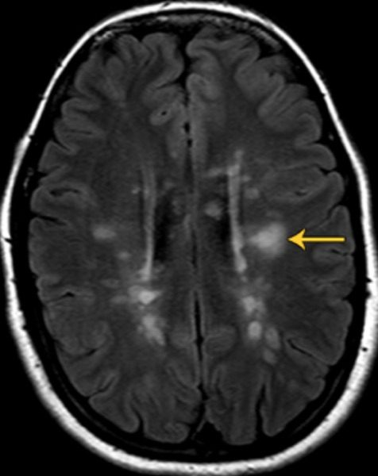  Optic neuritis — the MRI  Periventricular T2 FLAIR lesions — the demyelination behind it  Slide 23

Facet | Content
Epidemiology | 18 to 45 years old, 75% female — a much younger group than everything else in this block
Etiology | Inflammation due to multiple sclerosis, autoimmune disorders, postviral, or idiopathic
Symptoms | Unilateral vision loss over hours to several days, with PAINFUL EYE MOVEMENT. Often central vision loss and loss of colour vision
Signs | Often a normal-appearing disc. Relative afferent pupillary defect (Marcus Gunn)
Diagnosis | Refer to ophthalmology. Complete ophthalmic exam — slit lamp, dilated fundoscopy, colour vision assessment — plus a neurological exam. MRI brain AND orbits, with and without contrast
Escalation | If MRI shows at least 2 characteristic demyelinating lesions, ophthalmology treats and refers to neurology or neuro-ophthalmology
Treatment | Corticosteroids if a demyelinating cause is found
Prognosis | Spontaneous recovery is the rule. Without treatment vision begins improving within a few weeks, may continue for months, and is usually normal within a year
Education | Recurrence carries a greater risk of multiple sclerosis. Do not treat the episode and stop — find out why it happened, or you miss the bigger problem


Periventricular demyelinating lesions on MRI. Two or more is the threshold that sends the patient on to neurology. Slide 23

3.5 · Retinal detachment Objective a4
What these look like
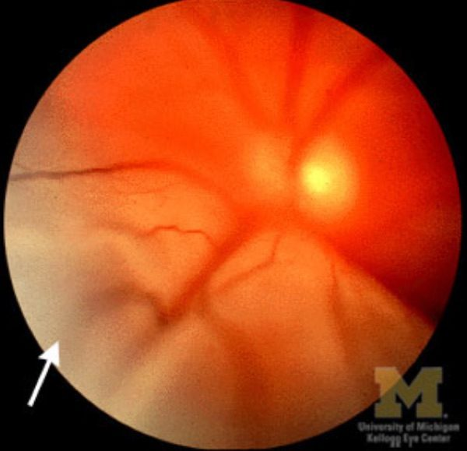
Retinal detachment
Elevated grey retina thrown into folds
Slide 28

Facet | Content
Pathophysiology | Traction detachment that commonly follows a retinal tear or hole. Three types: rhegmatogenous, traction, serous/exudative
Epidemiology | Most common after age 50 — the vitreous humor shrinks with age
Risk factors | Myopia (contracted ciliary muscle), trauma, cataract extraction, diabetes, tumour, connective tissue disease, family history
Early symptoms | New flashing lights and floaters — these represent the retinal TEAR, not the detachment itself
Then | Grey or black shadows in the peripheral field, which may cover the whole eye within days. A “curtain or dark cloud” across the field
The escalation | If the macula is involved → sudden loss of vision in that eye
Odd but useful | The visual loss can change with head position, because the detached retina is floating loose
Diagnosis | Direct and dilated ophthalmoscopy: retina elevated, grey cloud with folds, a pigmented well-demarcated area, and tears that are orange and crescent shaped. Ultrasound is MORE SENSITIVE than the fundoscopic exam and determines the type
Treatment | EMERGENCY — refer immediately. Surgical repair urgently or within a week depending on type. Options: laser photocoagulation, cryotherapy, pneumatic retinopexy, vitrectomy, scleral buckle


The detached upper retina — opaque and cloudy, vessels no longer visible, with the characteristic “billowy folds” . Slide 28
NOTE
Her disposition, verbatim in substance: this one needs to be seen right now. If no ophthalmologist can take them, they go to a hospital that has one. Not tomorrow.

3.6 · The four retinal vascular occlusions Objective a5
 | CRAO — artery | CRVO — vein
Mechanism | Embolus — arteriosclerosis, atherosclerosis, carotid or cardiac emboli | Thrombus occluding the central retinal vein
Frequency | Less common | MORE common than CRAO
Onset | Painless profound loss over a few SECONDS | Sudden and painless; sometimes gradual over days to weeks
Acuity | Counting fingers to light perception; an “island” of vision in the temporal field | Blurring to loss
Pupil | Slow to direct light, but BRISK when the other eye is illuminated — she called this a huge clinical clue | —
Fundus | Pale swelling of the posterior segment with a CHERRY-RED SPOT at the fovea; emboli visible in the central artery | “BLOOD AND THUNDER” — disc swelling, venous dilation, cotton wool spots, retinal haemorrhages
Risk factors
Later
Confirmatory
Treatment | Prompt. High-concentration inhaled oxygen and digital massage over the eyelid; IV acetazolamide to lower pressure; anterior chamber paracentesis; thrombolytic infusion into the ophthalmic artery within 8 hours | Urgent ophthalmology referral to restore blood flow; evaluate and treat the underlying disorders

★ PROFESSOR EMPHASIS
★ The number, and the reason
CRAO is a stroke in the eye. Irreversible retinal damage may occur after 90 minutes. And the systemic implication matters as much as the eye: the retinal arteries are tiny, so if plaque broke off the carotid and reached one, there is a great deal more plaque still in that carotid — stroke risk rises at the onset of a retinal artery occlusion.

The branch forms. BRAO and BRVO are the same disease as their central counterparts, differing only in where the blockage sits. A branch vessel is occluded rather than the main trunk, so only part of the retina is affected and the field loss is partial and localised rather than widespread. Everything else — risk factors, workup, referral — is the same. Jaquith was explicit that this is all there is to it.

3.7 · Papilledema
What these look like
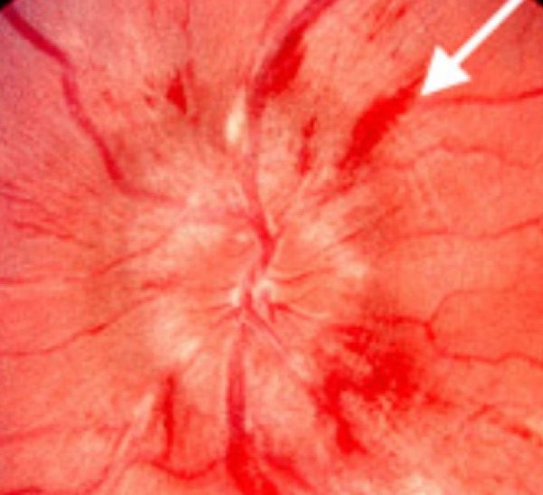  Papilledema — acute  Acute: blurred disc margins with flame haemorrhages  Slide 45 | 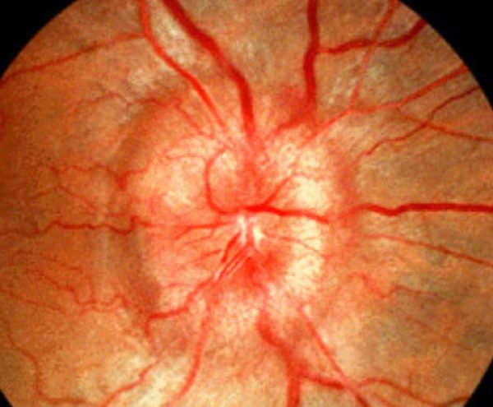  Papilledema — chronic  Chronic: disc elevation and blurred margins, no haemorrhages  Slide 45

NOTE
This is the one condition here that is NOT about intraocular pressure. Papilledema is swelling of the optic disc caused by raised INTRACRANIAL pressure — pressure inside the skull pushing on the optic disc. Every other pressure in this block is inside the globe. She drew the line explicitly.

Facet | Content
Causes | Tumour, trauma, intracranial infection (meningitis), haemorrhage, vitamin A toxicity
Visual symptoms | Non-specific: flickering vision, blurry vision, double vision
Systemic symptoms | Non-specific signs of raised intracranial pressure: nausea, vomiting, headache
Fundus | Engorged retinal veins, swollen optic disc, with or without retinal haemorrhages
Diagnosis | Lumbar puncture — an increased opening pressure confirms raised intracranial pressure. MRI and/or CT head to rule out a mass lesion
Treatment | Treat the underlying disorder

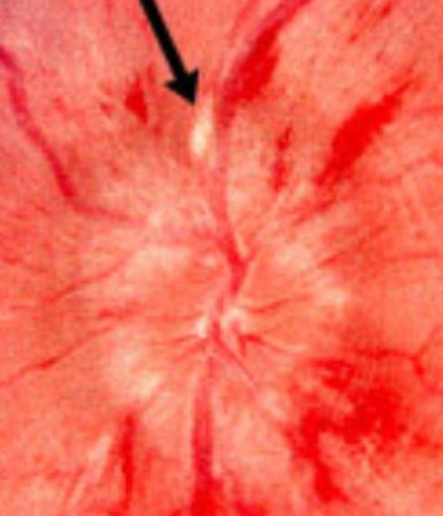
Acute papilledema. Left, haemorrhages ; right, a cotton wool spot . Slide 45 A and B
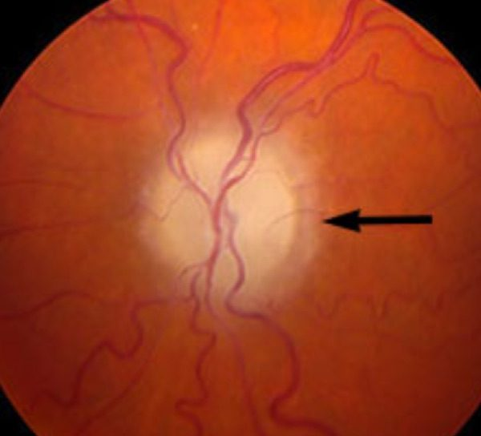
Left, chronic papilledema — disc elevation and blurred margins, but no haemorrhages or cotton wool spots . Right, the atrophic phase — the optic nerve axons have died. Slide 45 C and D
NOTE
Papilledema pushes the disc OUT. Glaucoma cups it IN. She stressed how distinctly different the two look, and it is the single most reliable way to tell them apart at the fundus.

3.8 · Anterior ischemic optic neuropathy Objective a6
Definition: sudden loss of blood flow to the front part of the optic nerve — the optic disc, causing rapid, painless vision loss. Common to both forms: sudden painless loss of side or central vision, swelling and PALENESS of the optic nerve head, and involvement of one eye first, though the second eye is at risk.
 | ARTERITIC (AAION) | NON-ARTERITIC (NAION)
Share of cases | The minority | 90–95%
Age | 55 and older | 40 to 60
Cause | Giant cell (temporal) arteritis — inflammation of the blood vessels | Linked to a small structural optic disc — a “disc at risk”
Associations | Systemic: malaise, weight loss, fever, headache in the temporal or occipital region, scalp tenderness (classically on combing the hair), jaw claudication on eating or chewing | Hypertension, diabetes, high cholesterol, sleep apnea
Urgency | MEDICAL EMERGENCY. Refer emergently any patient over 50 with sudden visual loss | Not emergent once arteritis is excluded
Workup | ESR and CRP — the tests used to rule giant cell arteritis in or out. Temporal artery biopsy is the gold standard | A diagnosis of EXCLUSION. The workup is identical — you are making sure there is no giant cell arteritis — then medical evaluation for hypertension, diabetes and anaemia, with neuroimaging if unclear
Treatment | IV methylprednisolone for 3 days, then a slow oral taper to the lowest dose that suppresses the disease, guided by symptoms and labs — typically 6 to 12 months. Add famotidine for gastrointestinal ulcer prophylaxis | Observation and cardiovascular risk factor modification. Consider avoiding antihypertensives at bedtime, since nocturnal hypotension can worsen it
Prognosis | Depends on how long it has been present and when corticosteroids started. Early therapy is critical — untreated it leads to blindness. Follow up with ophthalmology | Follow up with ophthalmology

NOTE
Her boundary on giant cell arteritis. “I'm not going to test you on GCA directly, I promise you — but it's kind of hard when I know GCA is what's causing this not to explain GCA to you.” So learn it as the cause of arteritic AION and the reason that presentation is an emergency, not as a rheumatology topic in its own right.
The picture she painted: an elderly woman, usually Caucasian, over 55, with no history of headaches, who suddenly has a temporal headache. That change from no headaches to a new one is the warning sign.

3.9 · Care strategies — adult and elderly Objective b
Presentation | Disposition
Sudden painless monocular loss, any cause | Stroke until proven otherwise — MRA, and urgent ophthalmology
CRAO | Emergency department NOW — the retina is lost after 90 minutes
Retinal detachment | Same day, to a hospital with an ophthalmologist if clinic cannot take them
Acute angle-closure glaucoma | Emergent — lower the pressure medically, iridotomy in 1–2 days
Any patient over 50 with sudden vision loss | Emergent ophthalmology, plus ESR and CRP for arteritic AION
CRVO / BRVO / BRAO | Urgent ophthalmology to restore flow; treat the underlying disorder
Optic neuritis | Refer to ophthalmology; MRI brain and orbits; neurology if 2 or more lesions
Papilledema | Imaging to exclude a mass, then lumbar puncture; treat the cause
Chronic open-angle glaucoma | Routine — but annual eye exams are how it gets found at all

First-line treatment
Every condition in this lecture, with what you reach for first and how fast — which in ophthalmology is half the answer. Where the deck escalates after a failed trial, only the first step is here; the full ladder and the reasoning are in the comparison chart.
Condition | First line | How fast
Amaurosis fugax | Treat the underlying cause. Aspirin and clopidogrel for stroke risk; carotid endarterectomy for carotid emboli; calcium channel blockers for vasospasm. | Urgent
Acute angle-closure glaucoma | Topical pilocarpine or timolol; IV acetazolamide then mannitol or isosorbide. Definitive: laser peripheral iridotomy, 1–2 days after onset. | Emergent
Chronic open-angle glaucoma | Latanoprost, tafluprost or timolol drops. | Routine
Optic neuritis | Corticosteroids if a demyelinating cause is found. At least 2 demyelinating lesions → neurology or neuro-ophthalmology. | Urgent
Retinal detachment | Refer immediately. Surgery urgently or within a week by type: laser photocoagulation, cryotherapy, pneumatic retinopexy, vitrectomy, scleral buckle. | Emergent
Central retinal artery occlusion (CRAO) | High-concentration inhaled oxygen and digital massage, IV acetazolamide, anterior chamber paracentesis, and thrombolytic into the ophthalmic artery within 8 hours. | Emergent
Branch retinal artery occlusion (BRAO) | As for CRAO — the management does not change. | Emergent
Central retinal vein occlusion (CRVO) | Urgent ophthalmology referral to restore blood flow. Evaluate and treat the underlying disorders. | Urgent
Branch retinal vein occlusion (BRVO) | As for CRVO — urgent referral, and treat the underlying disorder. | Urgent
Arteritic AION (giant cell arteritis) | IV methylprednisolone ×3 days, then a slow oral taper to the lowest suppressive dose, typically 6–12 months. Add famotidine for ulcer prophylaxis. Do not wait for the biopsy. | Emergent
Non-arteritic AION | Observation and cardiovascular risk factor modification. Consider avoiding antihypertensives at bedtime. | Urgent
Papilledema | Treat the underlying disorder. | Emergent

4 · Chronic Vision Loss & Tumors of the Eye
INSTRUCTIONAL OBJECTIVES
OPHTHALMOLOGY — Chronic Vision Loss and Tumors
- Compare and contrast the etiologies, epidemiology, risk factors, clinical manifestations, differential diagnosis, diagnostic testing (including ordering and interpretation), management (including applicable rehabilitative and palliative care), appropriate referrals, patient education, and prognosis for the following chronic vision loss disorders and tumors of the eye:
- Cataract — congenital, acquired
- Age related macular degeneration — wet, dry
- Primary open angle glaucoma
- Astigmatism
- Hyperopia
- Myopia
- Strabismus
- Amblyopia
- Idiopathic intracranial hypertension
- Neoplasms, malignant: retinoblastoma, melanoma, squamous cell carcinoma
- Neoplasms, benign: nevus
- Identify medical care strategies for common ophthalmological disorders in infant, adolescent, adult, and elderly populations.

NOTE
How this section is organised, and the one line that carries it. Everything here is slow — the opposite of section 3. Beck came back to the same question repeatedly: what is the most common cause? She said it outright — “it’s always important to know the most common causes of things, because you’ll see them most commonly.” That list is the spine of the section: amblyopia for childhood vision loss, uveal melanoma for adult eye cancer, primary open-angle for glaucoma, zonular for paediatric cataract, and the liver for where ocular melanoma goes.

4.1 · Idiopathic intracranial hypertension
Also called pseudotumor cerebri, and both terms are used. It is almost exclusively a disease of overweight women of childbearing age, and it comes on so slowly that the symptoms sound like everyday complaints.
Symptoms | Intractable headache of variable character · transient visual loss that comes and goes · intracranial noises — pulsatile tinnitus · pain behind the eyes · mild pain on eye movement or globe compression
Signs | Papilledema · visual field loss · abducens (sixth nerve) palsy. Not all are present at once — it depends how long it has been running.
Order first | MRI brain with MR venography. A new or changing headache always prompts imaging, and venography is there to exclude a cerebral venous sinus thrombosis, which raises pressure the same way.
Then confirm | Lumbar puncture — elevated opening pressure. That is the diagnosis. Note this is intracranial, not systemic, hypertension: the blood pressure may be perfectly normal.
Management | Acetazolamide promptly, plus a weight reduction programme with a dietitian. Surgical CSF diversion — optic nerve sheath fenestration or a shunt — only for those who fail or cannot tolerate medical therapy.
Prognosis | Followed jointly by ophthalmology and neurology. Weight loss is the only thing that permanently fixes it; medication covers the patient while that happens.

Beck's framing: if an overweight woman of childbearing age comes in with vague headache, keep this in the back of your mind. The symptoms are ordinary; the demographic is the clue.

4.2 · Primary open-angle glaucoma
The most common form of glaucoma, and the mirror image of the acute angle-closure form in section 3: painless, slow, and silent until damage is done.
The angle | Open-angle means the angle between iris and cornea is wide. Closed-angle is the narrow, acute one. That geometry is the whole distinction.
What is lost | Peripheral field first, with central acuity initially spared — vision narrows like a tunnel. Macular degeneration does the opposite.
Signs | Cupping (excavation) of the optic nerve, characteristic field loss on perimetry, and often a raised intraocular pressure.
Risk factors | Raised intraocular pressure · advanced age · race · family history.
Treatment | Drops that either make less aqueous (beta blockers such as timolol, carbonic anhydrase inhibitors, alpha-2 agonists) or drain more (prostaglandin analogues), then laser or surgery.
Prognosis | Damage already done cannot be reversed. Treatment preserves what is left. That is the entire argument for screening someone who feels fine.

Beck on referrals: an ophthalmologist is a physician and surgeon; an optometrist handles refraction and lens fitting. Medical eye disease — and every diabetic, annually — goes to ophthalmology. Make that explicit when you write the referral.

4.3 · Age-related macular degeneration
What these look like
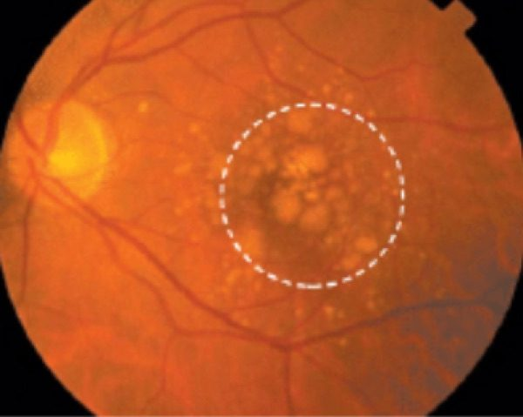  Age-related macular degeneration — dry  Soft drusen — large, pale, indistinct deposits at the macula  Slide 11 | 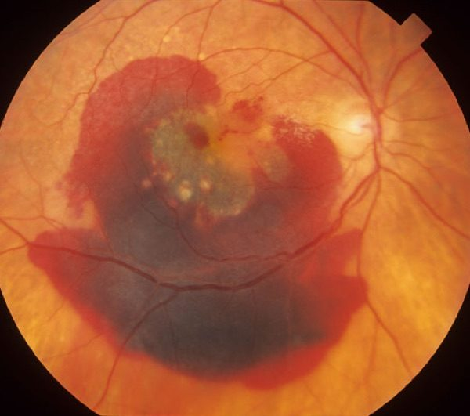  Age-related macular degeneration — wet  Haemorrhage from new choroidal vessels bleeding into the retina  Slide 11

80% dry, 20% wet. Risk factors are age, cigarette smoking and probably genetics; the exact cause is unknown.
Dry (non-exudative) | Drusen, pigmentary change and atrophy. Blurred central vision with a central scotoma.
Wet (exudative) | Choroidal neovascularisation bleeds into the retina, and the blood organises into a disciform scar. That scar is why the central vision goes. Once it has bled it stays classified as wet.
How dry turns wet | Waste products accumulate under the macula and disrupt the retina; new vessels grow behind it, causing swelling, bleeding and scarring — hence the rapid change on a slow background.
Monitoring | Amsler grid at home and serial slit lamp review. For wet, add fluorescein angiography and optical coherence tomography.
Management | STOP SMOKING. Dry: AREDS2 — vitamins C and E, zinc, copper, lutein, zeaxanthin. Wet: intravitreal anti-VEGF, thermal laser, photodynamic therapy.
Prognosis | Treatment slows progression but does not reverse vision already lost.

NOTE
Why the supplement changed. The original AREDS trial in 2001 recommended high-dose beta carotene. AREDS2 in 2013 dropped it, because beta carotene raised lung cancer risk in smokers — the very group most likely to have the disease.

4.4 · Refractive errors
Emmetropia is normal refraction, and is not an error. The three errors differ only in where the image lands.
Myopia — nearsighted | “Long eyeball”, generally an over-protruding cornea. Too much refractive power, so distant objects focus in front of the retina. Corrected with a concave, negative dioptre lens that scatters light and moves focus back.
Hyperopia — farsighted | “Short eyeball”, generally a flat cornea. Too little power, so objects focus behind the retina. Corrected with a convex, positive dioptre lens that converges light forward. Risk factors are anything shortening axial length — trauma pushing the lens back, or a mass behind the globe.
Astigmatism | Uneven curvature of cornea or lens, so no single point focus forms — multiple focal points, blur at every distance. Corrected with a toric lens.
Presbyopia | Listed as a non-refractive error — the age-related loss of accommodation.

Refer isolated refractive error to optometry. And the discriminator that matters clinically: refractive blur corrects fully with lenses. Beck's version — “if you have schmutz, putting glasses in front of the schmutz isn't going to help.”

4.5 · Strabismus
Misalignment, from any level: brain, cranial nerves, neuromuscular junction, or the extraocular muscles themselves.
The adult symptom | Diplopia that disappears on covering either eye — that is what makes it binocular, and therefore mechanical.
Signs | One eye fails to track or fixate, or does not move fully in some direction. Cover test elicits fixation of the misaligned eye. In moderate to large deviations the corneal light reflex is displaced.
Cranial nerve causes | Three — ptosis, pupil involvement, exotropia with vertical deviation. Four — vertical diplopia, worse on downgaze. Six — horizontal diplopia, esotropia.
Other differentials | Myasthenia gravis — variable ptosis and diplopia, mimics any pattern. Thyroid eye disease restricts movement. Down syndrome carries a higher prevalence of esotropia; cerebral palsy associates with strabismus and nystagmus.

4.6 · Amblyopia
What these look like
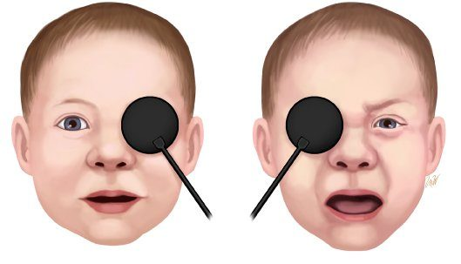
Amblyopia
Occlusion objection — content until the GOOD eye is covered
Slide 32

The most common cause of vision loss in children, affecting 3–5%. One eye fails to reach normal acuity even with correction, because the brain has stopped listening to it.
Three routes in | Strabismus — misalignment, so the brain suppresses one image. Anisometropia — a large difference in prescription between eyes. Deprivation — anything blocking the view: cataract, ptosis, corneal opacity, an eyelid haemangioma.
Occlusion objection test | The child is unbothered when the amblyopic eye is covered and becomes fussy when the good eye is covered. Losing the eye they actually use is what upsets them.
Defining it | Unilateral amblyopia is a two-line or greater difference in best corrected acuity between the eyes.
Screening | The US Preventive Services Task Force and the American Academy of Pediatrics recommend screening all children under five. Pre-verbal children need optotype tests rather than a Snellen chart.
Treatment | Patch the good eye, or blur it with atropine drops, forcing the weaker eye to work. Beck's analogy: you cannot build the weak arm by bench pressing with both — the strong one takes over.
Prognosis | Good if treated before seven, better before five. Many do not reach fully normal acuity.

NOTE
The part patients notice years later. Corrected too late, acuity can still improve, but stereo vision does not develop. The brain takes input from one eye at a time. These are the adults who say 3D films do nothing for them, or who misjudge distance driving at night — and it traces back to an untreated lazy eye.

4.7 · Cataract
What these look like
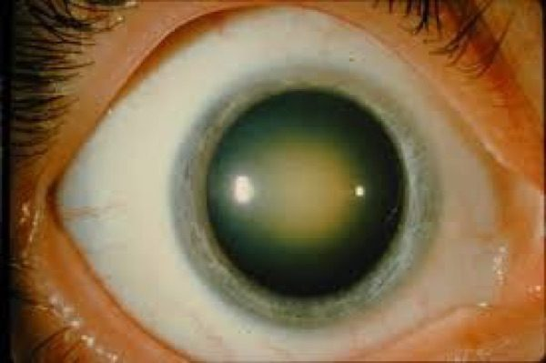  Cataract — nuclear  The lens centre yellowed and dense  Slide 37 | 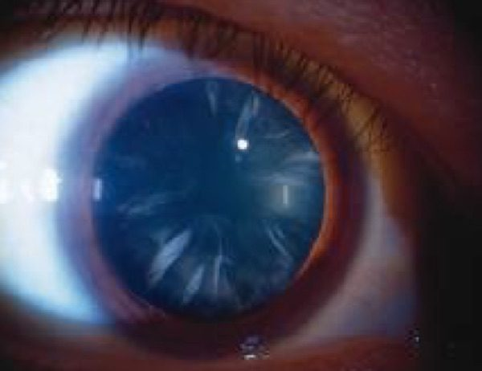  Cataract — cortical  Spokes running in from the lens edge  Slide 37 | 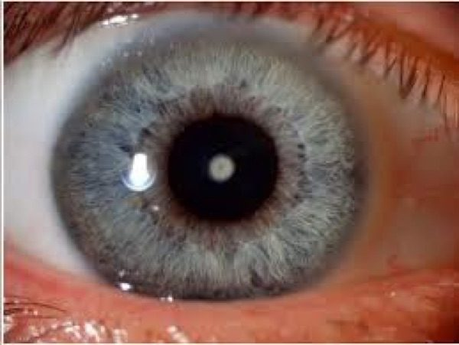  Cataract — pediatric  Polar cataract — a discrete opacity at the lens pole  Slide 38

Lens proteins break down and clump, clouding the lens. Beck's image: like looking through a foggy window. Ageing is the commonest cause overall; the commonest paediatric cause is idiopathic. Add diabetes, corticosteroid use, smoking and ultraviolet exposure.
Acquired — nuclear | Brown discoloration of the central lens. Blurs distance more than near — a myopic shift, which is why some patients find they can read without glasses again.
Acquired — posterior subcapsular | Plate-like opacity at the back of the lens; slit lamp shows a dark shadow against the red reflex. Glare and trouble reading, and characteristically better after dilation. More rapid onset, classically under 50, and typically on corticosteroids or diabetic.
Acquired — cortical | Radial, spoke-like opacities in the periphery. Asymptomatic until it reaches the centre, at which point glare is the most common complaint.
Paediatric | Zonular is the commonest — white opacity surrounding the nucleus. Polar is less common but central, so it is caught more easily. Also nuclear, and posterior lenticonus.
Signs | Early: slit lamp. Advanced: loss of the red reflex, leukocoria, a pupil that looks grey or white. A cataract alone does NOT cause a relative afferent pupillary defect — if there is one, look further.
Management | Non-urgent referral unless secondary to uveitis or glaucoma. Surgery is the only treatment and is deferred until it interferes with daily activities — except in a neonate, where it is done early to prevent amblyopia, or where the cataract blocks diagnosis or treatment of another eye disease.
Prognosis | Recovery is prompt and near-complete in 99% of eyes with isolated cataract. Complications are infrequent: retinal detachment in a myopic eye, and posterior capsule opacification — the “cataract came back” — treated with a YAG laser.

Beck's test of whether to operate when glaucoma coexists: yes — because you have to see past the lens to assess the nerve behind it.

4.8 · The blurry-vision differential
A single framework for everything that clouds vision slowly, and what separates each.
Corneal opacity | Scarring from trauma or infection. On the cornea, not the lens.
Refractive error | Corrects fully with lenses.
Posterior capsule opacification | Post-operative, treated with YAG laser.
Macular degeneration | Central loss with distortion; the lens stays clear.
Glaucoma | Peripheral loss; may coexist with cataract.
Diabetic retinopathy | Retinal haemorrhages and exudates — retinal, not lenticular.
Uveitis | Pain, redness, photophobia; can cause a secondary cataract.
Optic neuropathy | Reduced acuity and colour vision, with a normal lens. The only one here that takes colour — think of it first when a patient reports colours washing out.
Functional visual loss | Normal examination, normal pressure, clear lens, and symptoms that do not fit anatomy.

4.9 · Retinoblastoma
What these look like
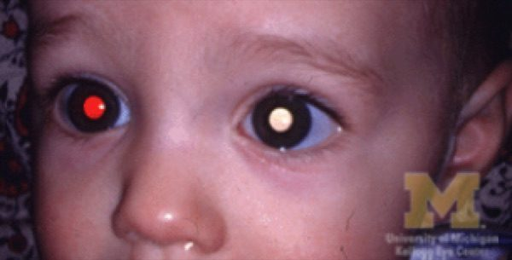
Retinoblastoma
Leukocoria — one pupil red, the other white
Slide 41

Rare, and almost exclusively in young children. A genetic mutation that is often recessive, so a clean family history does not reassure.
Presentation | Poor vision or a turned eye. The sign is leukocoria — and the classic story is a parent noticing one white pupil and one red one in a photograph.
Diagnosis | Dilated examination plus imaging. No biopsy — pathology is not needed and sampling risks seeding the tumour through the local tissue.
Primary care role | Check a red reflex in every infant and young child, and screen for subnormal vision. Refer suspicious cases within weeks — and chase it.
Family history | Referred to an ophthalmologist experienced in retinoblastoma, or an ocular oncologist, within the first eight weeks of life, even with a normal red reflex.
Prognosis | Untreated, close to 100% fatal. Treated, over 95% five-year survival. Metastasis usually appears within a year if untreated, and no recurrence at five years counts as cured — unusual language for a cancer.

NOTE
Beck was unusually direct about referral. If you are worried about a malignancy and the patient is offered an appointment in two months, you call the clinician yourself and get it moved. If they will not, document it and find someone who will. Her words: “we're not playing around with cancers.” A suspected retinoblastoma should be seen within a week.

4.10 · Uveal melanoma, nevus and conjunctival melanoma
What these look like
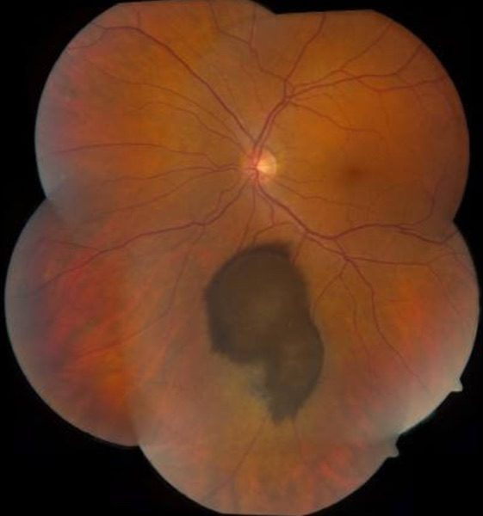  Uveal melanoma  Choroidal melanoma — a dome of pigment under the retina  Slide 44 | 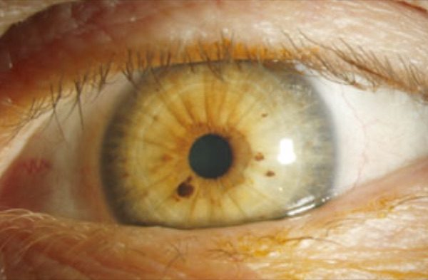  Iris nevus  Flat, under 3 mm, and no vessel of its own  Slide 48 | 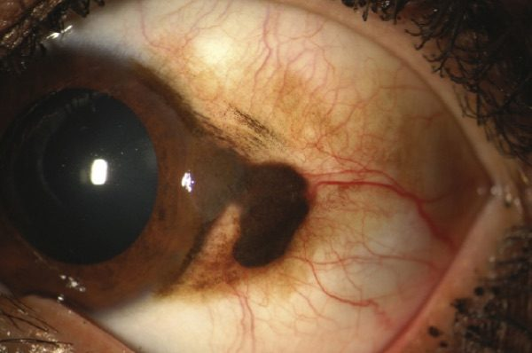  Conjunctival melanoma  Raised and vascular, unlike the flat cystic nevus  Slide 52

Uveal melanoma is the most common eye cancer in adults, arising from melanocytes of the choroid, ciliary body or iris. It is a distinct entity from cutaneous melanoma and from conjunctival melanoma.
Symptoms | Typically none — most are found incidentally on routine surveillance.
Iris melanoma signs | Slow-growing dark brown or translucent mass on the anterior iris, usually the inferior half, usually unilateral, over 3 mm at the base and over 1 mm deep, with a prominent feeder vessel. May pull the pupil out of shape (corectopia).
Nevus, by contrast | Apparent around puberty, asymptomatic, inferior iris, typically does not grow, flat or minimally elevated, uncommonly over 3 mm, and not vascular.
The discriminator | A cancer builds its own blood supply; a freckle does not. Growth, size and vascularity are what separate them.
Diagnosis | History, ophthalmic examination and imaging. Fine needle aspiration is for molecular prognostic testing and risk stratification, not to make the diagnosis.
Treatment | Radiation therapy is now the commonest, with enucleation less often needed — the eye is saved where possible.
Prognosis | Local control is usually effective, but many have already metastasised at diagnosis. The liver is the most common site. Ten-year mortality around 32% overall, but iris melanoma only 4–10% — because it is visible, and therefore found earlier.
Conjunctival melanoma | Raised and vascular, against a conjunctival nevus that is flat with clear cysts. Differentials include primary acquired melanosis (flat, patchy, can be premalignant) and racial melanosis (bilateral and symmetric).
Lisch nodules | Tan, bilateral, multifocal, non-progressive — and a pointer to neurofibromatosis type 1, alongside café-au-lait spots.

How Beck says to raise it with a patient: ask whether the freckle has always been there, then — without alarming them — send them to ophthalmology so its size can be documented and watched. Most are exactly what they look like.

4.11 · The differentials — what else looks like this
Each tumour and each macular disease comes with a list of mimics, and a vignette is far more likely to ask you to separate them than to name the obvious one.

Macular dystrophies that mimic age-related macular degeneration
Condition | What gives it away
Stargardt disease (late-onset) | Inherited macular dystrophy with yellow-white flecks and central vision loss
Sorsby fundus dystrophy | Autosomal dominant; choroidal neovascularisation that looks like wet degeneration
North Carolina macular dystrophy | Congenital and non-progressive macular changes resembling degeneration
Best disease (vitelliform) | Lipofuscin accumulation mimics drusen, but presents earlier in life

The common thread: all four are inherited and most present younger than age-related degeneration. A macular picture in a patient too young for it is the cue.

Leukocoria — what else besides retinoblastoma
Condition | What gives it away
Coats' disease | Idiopathic retinal telangiectasia with exudation, often unilateral
Persistent fetal vasculature | Congenital anomaly with remnants of fetal vasculature, typically unilateral
Toxocariasis | Parasitic infection causing granulomatous retinal inflammation
Retinal astrocytoma | Benign glial tumour, often with tuberous sclerosis
Medulloepithelioma | Rare tumour of the nonpigmented ciliary epithelium
Congenital cataract | Produces a white pupillary reflex without any tumour
Ocular toxoplasmosis | Retinal scarring and inflammation

Uveal melanoma by site
Uveal melanoma is named for where in the uvea it sits — iris, ciliary body or choroid — and an iris melanoma may be melanotic or partly amelanotic, so pigment is not required. Two signs point to a ciliary body lesion in particular: a sentinel vessel (a dilated episcleral vessel overlying the tumour) and extrascleral extension.

Iris nevus, and the pigmented iris differential
An iris nevus is a small pigmented, benign spot, usually apparent around puberty and asymptomatic. It sits in the inferior half of the iris, does not typically grow, is flat or minimally elevated (under 1 mm) and uncommonly over 3 mm across, and is usually not vascular. It may pull the pupil out of shape — corectopia.
Lesion | What separates it
Iris freckle | Flat, superficial pigment; no stromal involvement or distortion; usually bilateral and multifocal
Lisch nodules | Tan nodules of neurofibromatosis type 1; bilateral, multifocal, non-progressive
Melanocytoma | Dark brown, granular; usually benign but can cause secondary glaucoma through pigment dispersion
Melanocytosis | Congenital uveal pigmentation, sectoral or diffuse; raises the risk of uveal melanoma
Cogan-Reese (ICE) syndrome | Pigmented iris nodules with corneal endothelial abnormality; secondary glaucoma
Iris melanoma | Nodular or diffuse growth; may show vascularity, ectropion uveae, sectoral cataract or seeding
Metastatic carcinoma | Secondary deposit rather than a primary iris lesion

Risk factors that push an iris lesion toward melanoma: inferior location, diffuse configuration, and blood in the anterior chamber.

Non-pigmented conjunctival lesions
Conjunctival melanoma is pigmented, so the useful differential is the lesions that are not.
Lesion | What gives it away
Squamous cell carcinoma | Gelatinous or leukoplakic; can be mistaken for an amelanotic melanoma
Conjunctival lymphoma | Salmon-pink, painless mass, typically in the fornix or bulbar conjunctiva
Kaposi sarcoma | Reddish-purple vascular lesion, associated with HIV/AIDS
Pyogenic granuloma | Rapidly growing red mass, often after trauma or surgery

First-line treatment
Every condition in this lecture, with what you reach for first and how fast — which in ophthalmology is half the answer. Where the deck escalates after a failed trial, only the first step is here; the full ladder and the reasoning are in the comparison chart.
Condition | First line | How fast
Idiopathic intracranial hypertension | Acetazolamide promptly, plus a supervised weight reduction programme. Surgical CSF diversion (optic nerve sheath fenestration or shunt) only if medical therapy fails. | Urgent
Age-related macular degeneration — dry | STOP SMOKING. AREDS2 supplement: vitamins C and E, zinc, copper, lutein, zeaxanthin. | Routine
Age-related macular degeneration — wet | Intravitreal anti-VEGF injection, thermal laser photocoagulation, photodynamic therapy. | Same day
Cataract — nuclear | Surgery is the only treatment — lens extraction with implant, deferred until it interferes with daily activities. | Routine
Cataract — cortical | Lens extraction when it interferes with function. | Routine
Cataract — posterior subcapsular | Lens extraction. Review the steroid burden where that is the cause. | Routine
Cataract — pediatric | Surgery is NOT deferred in a neonate — it is done early to prevent amblyopia. | Emergent
Myopia | Concave (negative dioptre) lens — scatters light and moves focus back onto the retina. | Routine
Hyperopia | Convex (positive dioptre) lens — converges light forward onto the retina. | Routine
Astigmatism | Toric lens. | Routine
Strabismus | Treat the cause; ophthalmology referral. Untreated in a child it causes amblyopia. | Urgent
Amblyopia | Patch or atropinise the GOOD eye to force the weaker one to work. Treat the underlying cause. | Urgent
Retinoblastoma | Multimodal therapy under ocular oncology, with genetic counselling. Enucleation for large tumours. | Emergent
Uveal melanoma | Radiation therapy is now the commonest treatment; enucleation is less often needed. | Urgent
Iris nevus | Surveillance. More frequent initially to establish it is not growing, then annual dilated review. | Routine
Conjunctival melanoma | Specialist management under ocular oncology. | Urgent

5 · Ocular Trauma
INSTRUCTIONAL OBJECTIVES
OPHTHALMOLOGY — Ocular Trauma
- Compare and contrast the etiologies, epidemiology, risk factors, clinical manifestations, differential diagnosis, diagnostic testing (including ordering and interpretation), management (acute and chronic, including applicable rehabilitative and palliative care), appropriate referrals, patient education, and prognosis for ocular trauma:
- Foreign body
- Corneal abrasions
- Globe rupture
- Hyphema
- Lid lacerations
- Orbital and lid contusion
- Periorbital hematoma
- Retinal and vitreous detachments
- Blowout fractures
- Orbital fracture
- Basilar skull fracture
- Identify medical care strategies for common ophthalmological disorders in the lecture topic list for the following populations: 1. infant · 2. child · 3. adolescent · 4. adult · 5. elderly

NOTE
Before the eye, the patient. ABCs first — airway patent, breathing adequate, circulation present — then vital signs, neurological evaluation and the rest. An injured eye usually arrives attached to major trauma involving the brain, and the eyes may be assessed second. Always reason from the anatomy to what else could be damaged.
One point she added aloud that is not on a slide: the Glasgow Coma Scale runs from 3 to 15, not from 0. Three is the floor because each of its three components scores a minimum of one.

5.1 · The four rules that apply before any diagnosis
These come first because breaking one of them makes the injury worse.
Rule | Why
DO NOT REMOVE a penetrating object | It may be tamponading a wound. Removal in the emergency department can extrude intraocular contents.
CT orbit — never MRI | If the object is metallic, a magnetic field will move it through the eye.
NEVER dilate the eye when ocular trauma is suspected | It removes the pupil examination, which is one of the few windows onto what is happening inside.
Check tetanus status | Any penetration with metal or organic material — wood, leaf, dirt — carries the risk.

When is imaging automatic? Any loss of consciousness from trauma or alcohol, confusion, tachypnoea, apnoeic breathing, anticoagulant use, or eye penetration → CT without contrast.
Epidemiology worth carrying: ocular trauma is the leading cause of monocular blindness in young adult men in the United States.

5.2 · Assessing the patient
Establish the circumstance: who, what, where, when, and if you can, why. Blunt or sharp? High or low velocity? Prior ocular trauma? Nil-by-mouth status — what and when they last ate and drank — because surgery may follow. If the patient is intoxicated or has an altered level of consciousness, the history comes from family, friends or bystanders.
The ophthalmic examination is done without causing further damage and depends on how cooperative the patient is: inspect the eyes and periorbital tissues for lacerations, ecchymosis, proptosis, corneal clouding and hyphema; assess pupil size, shape and response to direct and consensual light; and if the patient is conscious and cooperative, test visual acuity and confrontation fields. Consult ophthalmology for anything needing further evaluation.
A practical aside: if no lid retractor is to hand, an unfolded paper clip bent with a hemostat will retract a lid.

5.3 · Open globe injury
A full-thickness defect in cornea and/or sclera, so the intraocular compartments are open to the outside. It splits into full-thickness eye wall laceration and globe rupture.
The signs to recognise: pupillary distortion, usually toward the wound; a flat anterior chamber; extraocular protrusion of uveal tissue; massive haemorrhagic chemosis; a soft eye; deep eyelid laceration; and intraocular blood as hyphema or vitreous haemorrhage.
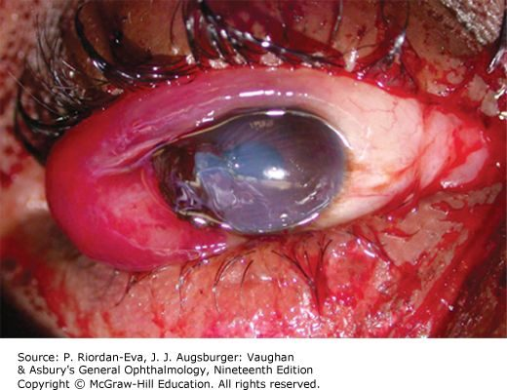  Full-thickness eye wall laceration  Cut clean through by a sharp object or high-velocity projectile  Slide 15 | 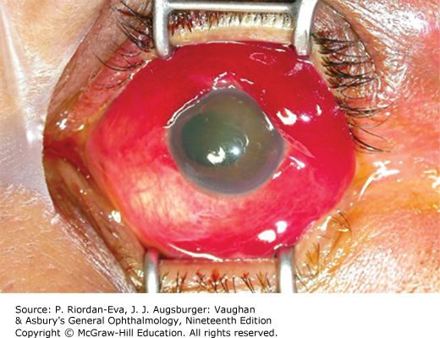  Globe rupture  Blunt force splitting the eye at a weak point  Slide 17

 | Full-thickness eye wall laceration | Globe rupture
Mechanism | Sharp object or high-velocity projectile — fishing hook, knife | Severe blunt force — airbag, fist, baseball
What happens | Cuts clean through cornea, sclera or both. The object may have been withdrawn, may be retained, or may have passed through with entry and exit wounds | Splits or tears at a weak point: posterior to the extraocular muscle insertions (especially superonasal), old surgical incisions, the lamina cribrosa
Extra | A cut lens capsule leaves the lens hydrated, oedematous and opaque; a fragment can extrude forward and inflame the anterior chamber. Lensectomy is required but often deferred. Posterior foreign bodies are left alone initially | Suspect it whenever blunt trauma gives massive haemorrhagic chemosis or a soft eye

The moment an open globe is suspected: a rigid protective shield taped over the eye, ophthalmology called immediately, antiemetics and analgesia so the patient does not strain or vomit, tetanus, and CT to exclude a foreign body. Then surgical repair.

5.4 · Corneal abrasion and foreign body
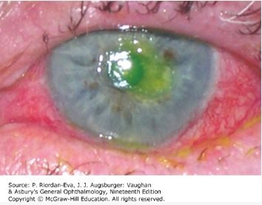  Corneal abrasion  Fluorescein staining the exposed basement membrane  Slide 18 | 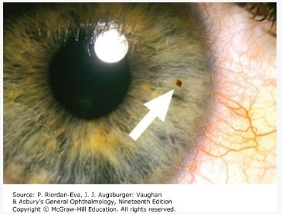  Corneal foreign body  Lodged after grinding or striking metal  Slide 21

Corneal abrasion — scraped corneal epithelium, one of the commonest ocular injuries, typically from a fingernail or handling a contact lens. Severe foreign body sensation, tearing, photophobia, blurred vision. Slit lamp with fluorescein stains the exposed basement membrane and shows the extent. Treat with a topical broad-spectrum antibacterial; patching may ease pain; re-examine to confirm healing.
NOTE
Never give a patient topical anaesthetic drops to take home. They delay healing, mask worsening symptoms, and can cause a corneal ulcer. This is the single most testable instruction in the section.

Foreign body — an object with too little momentum to pass through the eye wall lodges in cornea or conjunctiva. The history is grinding or striking metal. Linear vertical corneal epithelial defects mean the object is in the tarsal conjunctiva of the UPPER lid, so evert the lid and look. Removal: topical anaesthetic, slit lamp, sterile 27-gauge needle; a rust ring from iron or copper comes out with a battery-operated burr. Then broad-spectrum antibiotic and abrasion care. Refer if the object may have passed through the cornea — that is an open globe.

5.5 · Hyphema
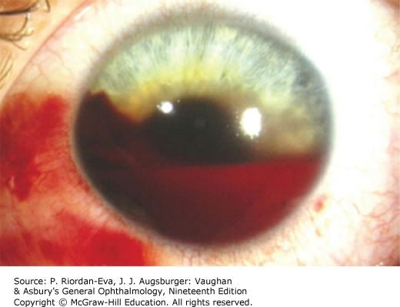
Hyphema
Blood layered in the anterior chamber, with a visible fluid level
Slide 24

Blood in the anterior chamber from injured vessels, after blunt or penetrating trauma. It can itself be a sign of open globe. Blurred vision, eye pain, photophobia. Diagnosed on diffuse light for a gross hyphema, then slit lamp and full ophthalmic examination.
Measure the intraocular pressure — unless a penetrating globe injury is suspected — and treat it if high, with beta blockers, pilocarpine, acetazolamide and osmotic agents if needed.
The whole of management aims at preventing a rebleed: bed rest with the head of the bed slightly elevated, antiemetics, ocular hypotensives, topical or oral corticosteroids, cycloplegic drops (atropine, homatropine, scopolamine) to rest the ciliary body, and oral aminocaproic acid, an antifibrinolytic that slows clot breakdown.
NOTE
Most rebleeding happens in the first 72 hours, and a secondary haemorrhage is what costs the vision permanently. Avoid aspirin and antiplatelet drugs. Risk is increased in sickle cell disease.

5.6 · Lid lacerations, contusion and periorbital haematoma
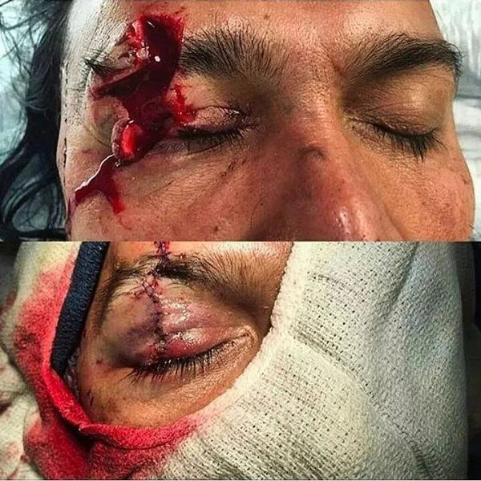  Lid laceration  Look underneath — two thirds of full-thickness cuts have a globe injury with them  Slide 29 | 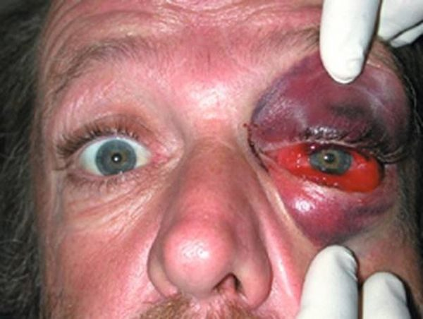  Orbital contusion  Swelling held in front of the septum, without haemorrhage  Slide 32 | 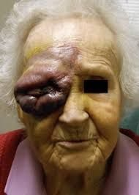  Periorbital haematoma  Bleeding behind the septum, within the bony orbit  Slide 34

Lid lacerations. Consult ophthalmology for any laceration that involves the lid margin, sits within 6 to 8 mm of the medial canthus, involves the lacrimal duct or sac, involves the inner lid surface, is associated with ptosis, or involves the tarsal plate or levator palpebrae.
- Full-thickness — comes with a corneal laceration or globe rupture in about two thirds of cases. Always look underneath.
- Partial-thickness — anything not meeting the criteria above. Can be repaired in the emergency department, with ophthalmology follow-up in 2 to 3 days.
A deep laceration to the medial third may transect the canalicular system, and if that is not repaired properly the patient has chronic tearing for good. Facial lacerations may be left open for 24 hours before closure, because the face is so well vascularised.
Orbital contusion is soft tissue swelling without haemorrhage. The tarsal plate and septal margin act as a wall holding blood in the anterior tissues, so it presents as preseptal ecchymosis or haematoma. Management is supportive through to surgery depending on the patient — and rule out brain trauma.
Periorbital haematoma is bleeding within the bony orbit. It is not always traumatic: orbit and eyelid surgery, peribulbar injections, orbital varices, lymphangiomas and arteriovenous malformations, anticoagulants, sickle cell disease, orbital pseudotumour and idiopathic causes all produce it. Management is canthotomy with cantholysis — exposing the lateral canthal tendon and cutting its inferior branch — to let the blood out.

5.7 · Retinal and vitreous detachment
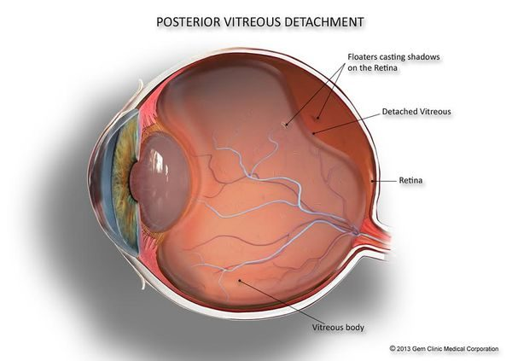  Posterior vitreous detachment  The event that usually precedes a rhegmatogenous detachment  Slide 37 | 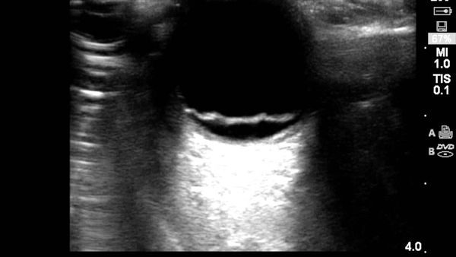  Retinal detachment on ultrasound  The detached retina as a bright membrane tethered in the vitreous cavity  Slide 38

The presentation is the same one that appears in section 3: a shadow or curtain descending over the eye, cloudy or smoky vision, floaters and momentary flashes of light, a monocular field defect, and central acuity dropping once the macula is involved. Diagnosis is history plus a dilated eye examination. The patient must be seen by ophthalmology within 24 hours.
What Lecture 14 adds is the three types, which do not share a treatment.
Type | Mechanism | Management
Rhegmatogenous  most common | One or more full-thickness breaks in the sensory retina, vitreous traction, and liquefied vitreous passing into the subretinal space. Usually preceded by posterior vitreous detachment. Mostly a spontaneous age-related event, brought forward by myopia, cataract surgery or trauma | Surgical. Ophthalmology STAT, pain control, antiemetics, head of bed at 30–40 degrees
Traction | Most commonly proliferative diabetic retinopathy. More localised and concave; begins along the vasculature then spreads to retina and macula | Surgical
Exudative (serous) | Neither a retinal break nor traction. Associated with systemic vascular or inflammatory disease, or an intraocular tumour | Manage the underlying condition

5.8 · Orbital floor (blowout) fracture
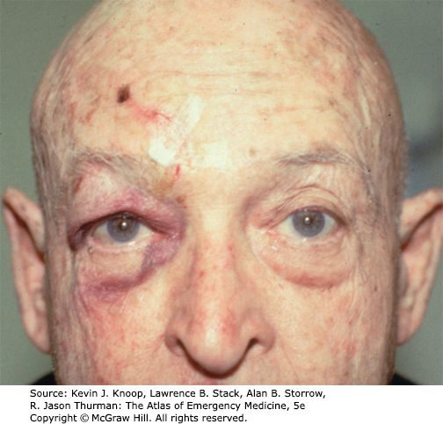  Orbital floor fracture  Periorbital ecchymosis and lid oedema after blunt force  Slide 42 | 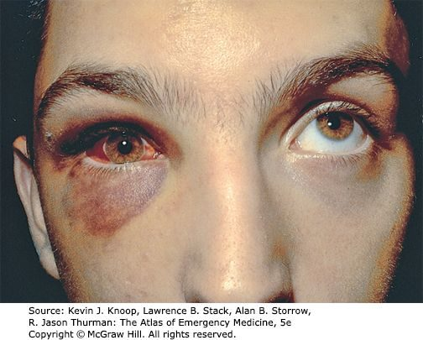  Inferior rectus entrapment  The right eye fails to elevate on upward gaze — diplopia looking up  Slide 42 | 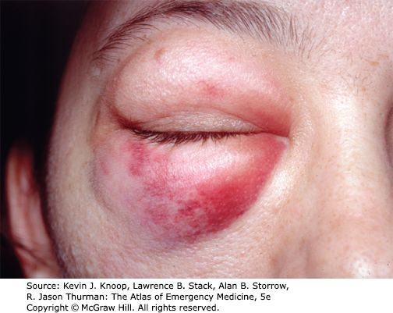  Medial wall fracture  Periorbital ecchymosis and swelling  Slide 42

Two mechanisms. A true blowout, where a blunt object — a fist, a ball — transmits energy to the globe, raising orbital pressure until the floor (most often) or medial wall gives way. Or force transmitted to the infraorbital rim, buckling the floor.
Findings: periorbital ecchymosis and lid oedema; chemosis, subconjunctival haemorrhage, and infraorbital numbness from injury to the infraorbital nerve; corneal abrasion, hyphema, enophthalmos, proptosis, iridoplegia, dislocated lens, retinal tear or detachment, ruptured globe; and periorbital subcutaneous emphysema.
NOTE
The gaze rule. Diplopia on UPWARD gaze means entrapment of the inferior rectus or its supporting structures. Diplopia on LATERAL gaze means entrapment of the medial rectus. Entrapment also brings severe pain and autonomic disturbance — bradycardia and vomiting on attempted eye movement.
In children, an entrapped muscle may come with no orbital soft tissue signs at all — the “white-eyed blowout”. A quiet-looking eye does not exclude it.

Diagnosis: CT of the orbits and midface. She gave the reason the midface is included: “to make sure there aren’t any additional structures that are also fractured … if their orbital floor is fractured, sure, okay, but we want to make sure we’re not missing any other fractures.” Management runs by severity:
- No eye injury or entrapment — ice and analgesia, follow up in 2 to 3 days.
- Blood in the maxillary sinus — antibiotics, and note that they are PROPHYLACTIC. Her reasoning: the eye is sterile, so blood in the sinus means the sinus has been disrupted and now has a portal of entry. “It’s not that we’re treating anything … it’s to make sure that it doesn’t become infected.”
- True blowout fracture — ophthalmology, because 30% sustain a significant globe injury.
- Muscle entrapment — facial trauma surgeon STAT, because a compromised blood supply means muscle necrosis.
If the optic nerve is already damaged, that damage is unlikely to improve and surgery may worsen it. Where surgery is planned, it is often delayed 1 to 2 weeks to let orbital swelling settle, so intraorbital pressure during the operation is lower.

5.9 · Basilar skull fracture
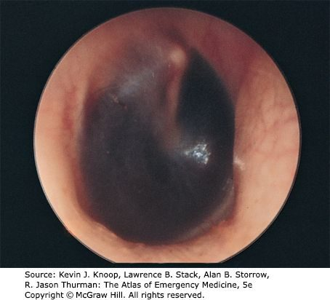  Haemotympanum  Blood behind the tympanic membrane  Slide 45 | 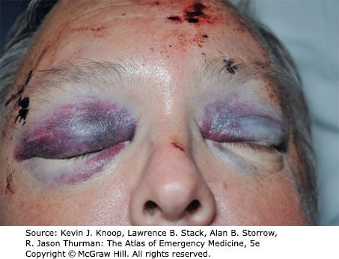  Raccoon eyes  Periorbital ecchymosis, without direct orbital trauma  Slide 45 | 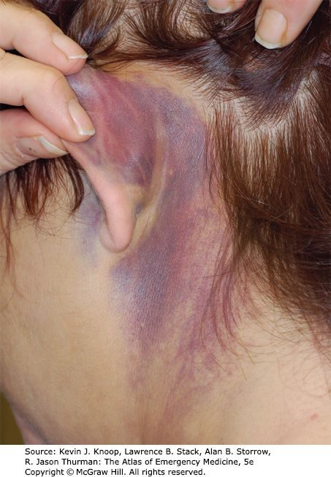  Battle sign  Retroauricular ecchymosis over the mastoid  Slide 45
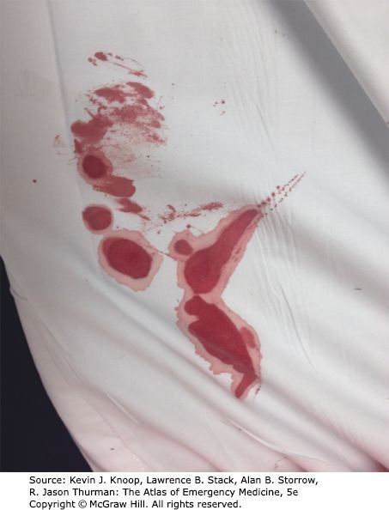
Halo (double ring) sign
Otorrhoea on a bedsheet: inner ring of blood, outer ring of cerebrospinal fluid
Slide 46

A linear fracture of the skull base — cribriform plate of the ethmoid, orbital plate of the frontal, petrous or squamous temporal, sphenoid, or occipital bone. Trauma there often produces no symptoms of its own, so it is found on indirect signs:
- Visible bleeding from the fracture into the soft tissue at the base of the head
- Raccoon eyes (periorbital ecchymosis) and Battle sign (retroauricular ecchymosis)
- Bleeding into the middle ear or sphenoid sinus; haemotympanum
- Cerebrospinal fluid leak — clear or pink rhinorrhoea
NOTE
Two bedside tests for cerebrospinal fluid. A dextrose stick may be positive. And fluid placed on filter paper — or found on the bedsheet — shows a halo or double ring sign: an inner ring of blood with an outer ring of cerebrospinal fluid.
How to actually do it. Hold a bedsheet, paper or tissue under the nostril, let the drip fall onto it, and watch as it dries — two rings appear, one inside the other. She was emphatic about this one: “that’s a very classic and that’s a very important sign for us to not miss.”

Diagnosis: CT orbits, though the fracture is not always evident on it. A cerebrospinal fluid leak means a neurosurgery consult and admission. Otherwise admission turns on the clinical condition, the associated injuries, and any brain injury seen on CT. Antibiotics for a cerebrospinal fluid leak are controversial, because of the risk of selecting resistant organisms.
First-line treatment
Every condition in this lecture, with what you reach for first and how fast — which in ophthalmology is half the answer. Where the deck escalates after a failed trial, only the first step is here; the full ladder and the reasoning are in the comparison chart.
Condition | First line | How fast
Open globe injury | Rigid protective shield taped over the eye and ophthalmology called immediately. Antiemetics and analgesia so the patient does not strain, plus tetanus. Surgical repair. | Emergent
Full-thickness eye wall laceration | Surgical repair. Lensectomy is required but is often deferred, to let hyphema and inflammation settle and to measure accurately for an intraocular lens. Posterior-segment foreign bodies are left alone at first assessment. | Emergent
Globe rupture | Shield, ophthalmology immediately, antiemetics, analgesia, tetanus. Immediate surgical repair with wound exploration. | Emergent
Corneal abrasion | Topical broad-spectrum antibacterial. Patching may ease pain. Re-examine periodically to confirm healing and exclude infection. | Urgent
Corneal or conjunctival foreign body | Topical anaesthetic, then removal with a sterile 27-gauge needle. A rust ring (iron or copper) comes out with a battery-operated burr. Broad-spectrum antibiotic plus abrasion care. | Urgent
Hyphema | Goal is preventing a rebleed: bed rest with the head elevated, antiemetics, ocular hypotensives, topical or oral corticosteroids, cycloplegic drops, and oral aminocaproic acid to stop clot breakdown. Treat a raised pressure. | Emergent
Lid laceration | Ophthalmology for any of: lid margin involvement, within 6–8 mm of the medial canthus, lacrimal duct or sac, inner lid surface, associated ptosis, tarsal plate or levator. Partial-thickness can be repaired in the emergency department with ophthalmology follow-up in 2–3 days. | Emergent
Orbital contusion | Supportive, through to surgery depending on the patient's condition. | Urgent
Periorbital haematoma | Canthotomy with cantholysis — releasing the lateral canthal tendon and cutting its inferior branch — to let the blood drain. | Emergent
Retinal detachment — rhegmatogenous | Surgical. Ophthalmology STAT, pain control, antiemetics, head of bed at 30–40 degrees. | Emergent
Retinal detachment — traction | Surgical. | Emergent
Retinal detachment — exudative | Treat the underlying condition — not primarily a surgical problem. | Urgent
Orbital floor (blowout) fracture | No injury or entrapment: ice, analgesia, review in 2–3 days. Blood in the maxillary sinus: antibiotics. True blowout: ophthalmology, because 30% have a significant globe injury. Entrapment: facial trauma surgeon STAT — the muscle can necrose. | Emergent
Basilar skull fracture | Cerebrospinal fluid leak: neurosurgery consult and admission. Admission otherwise turns on the clinical picture, associated injuries and any brain injury on CT. | Emergent

